1. Required error message not display while click add button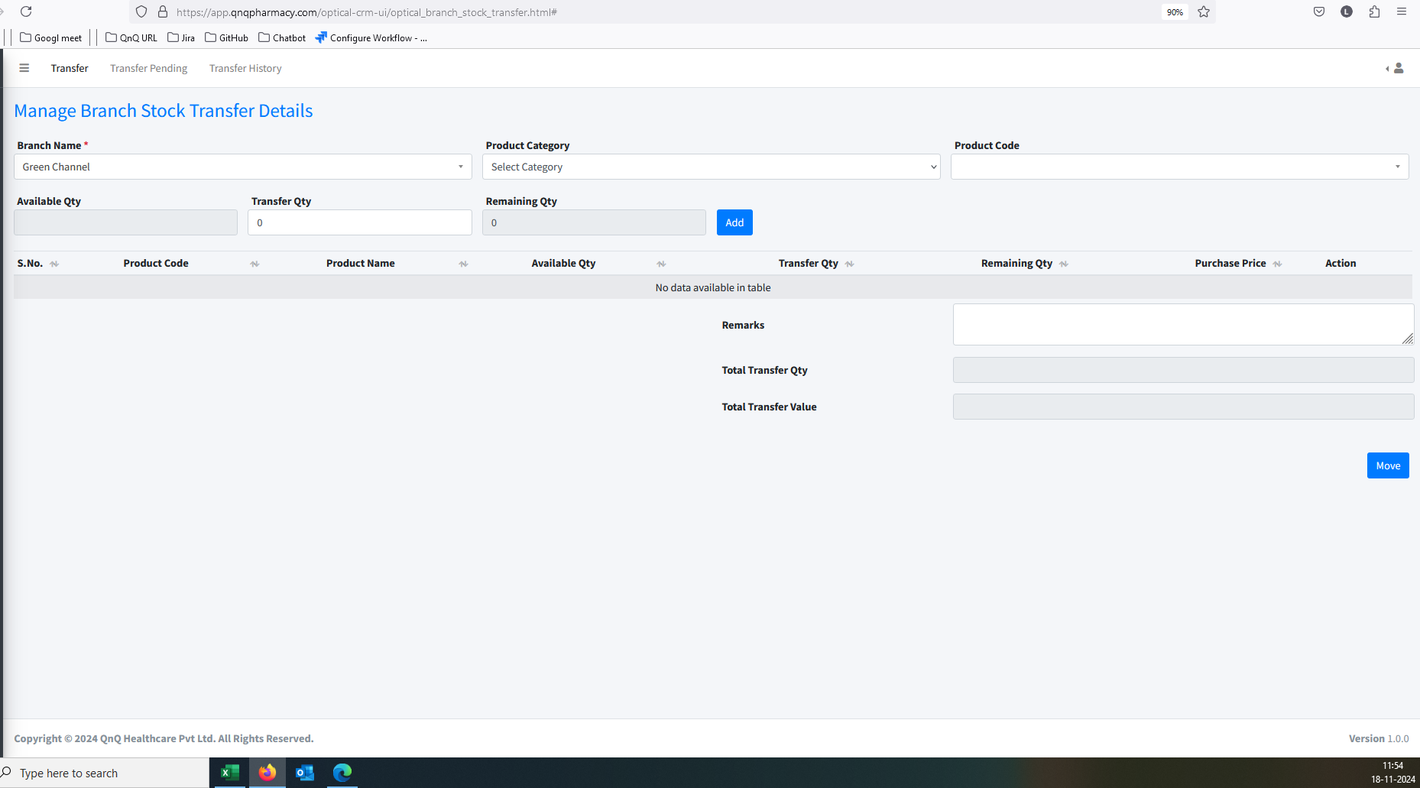 //
2. Mismatch error message display while click Move button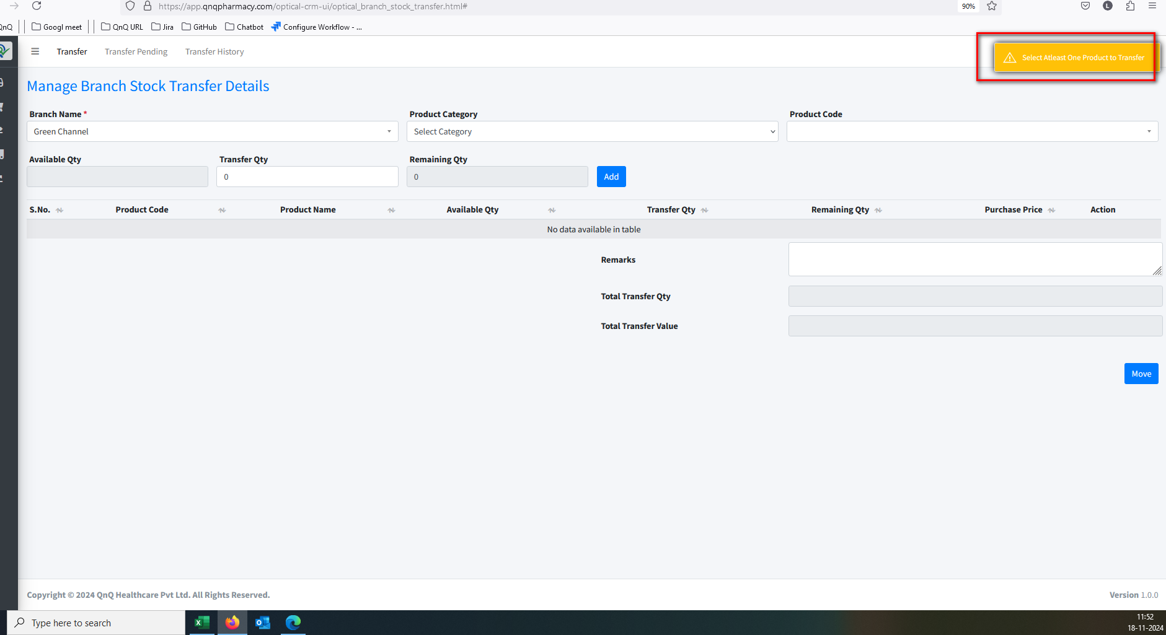//
3. Mismatch error message display while give invalid value in Transfer QTY //
4. Mismatch button name display in add new entry page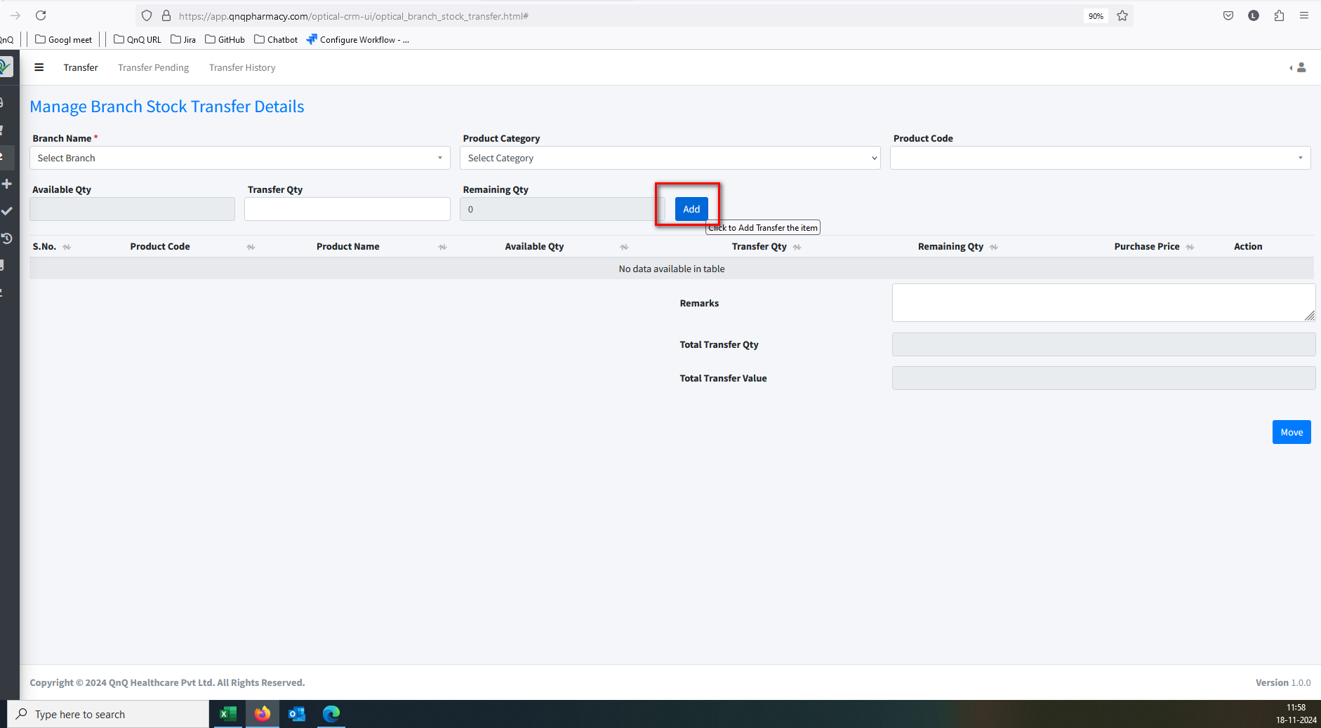//
5. Mismatch tool tip display in Add Product button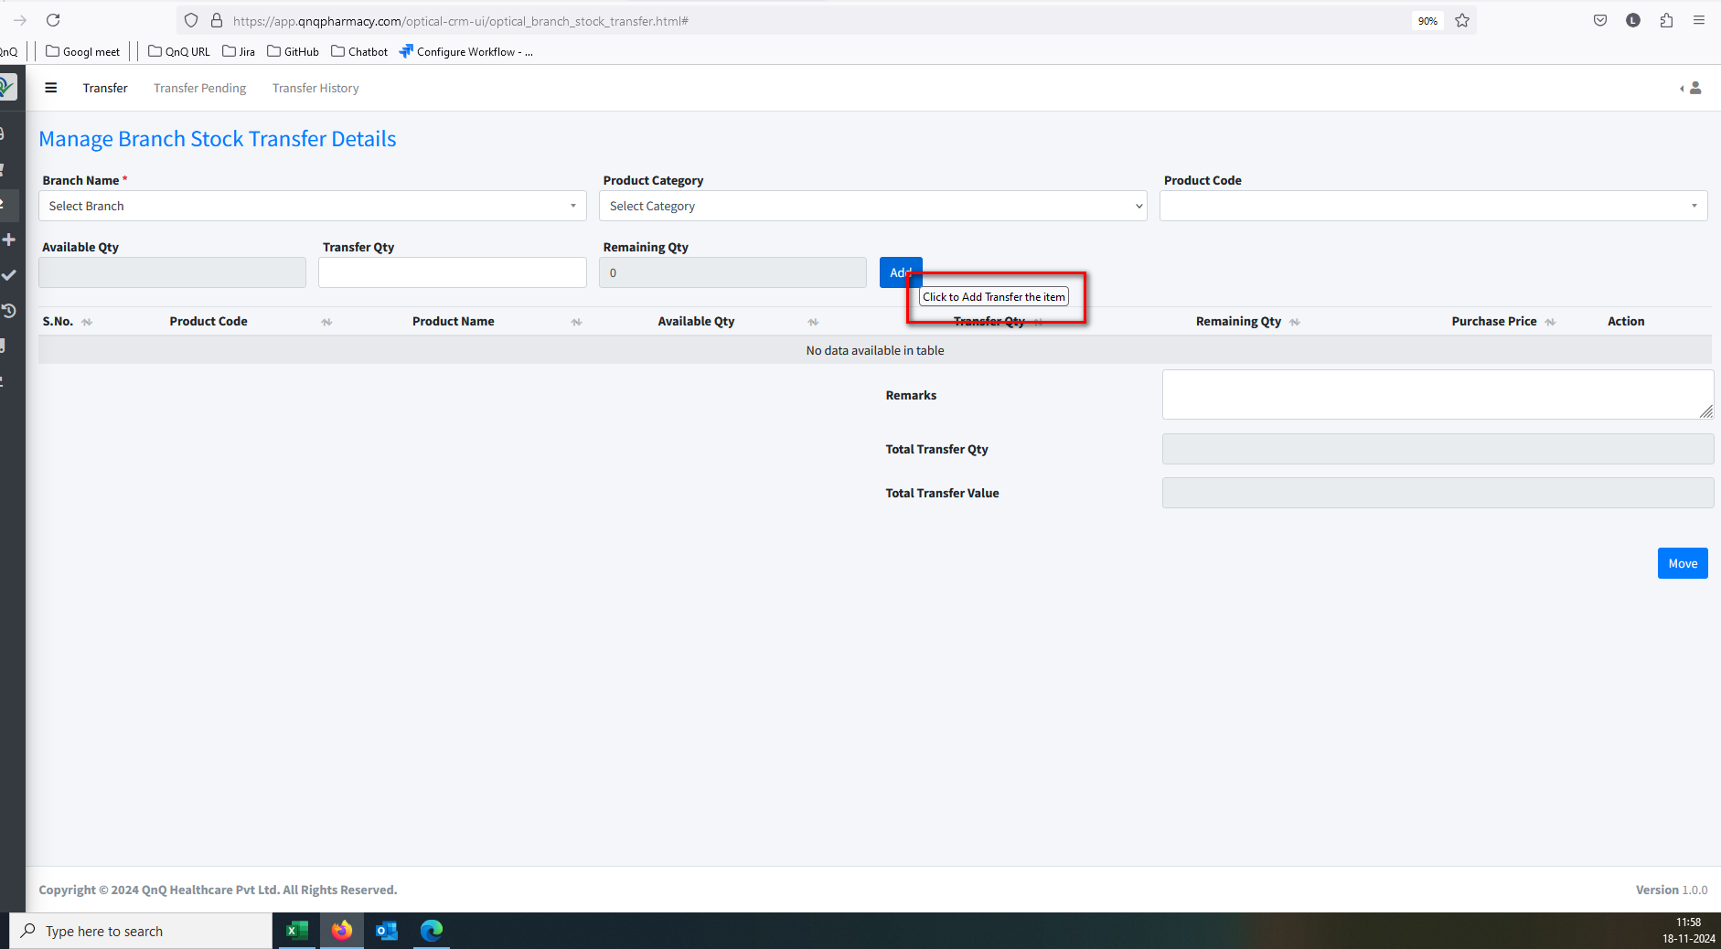//
6. Tool tip not display in Move button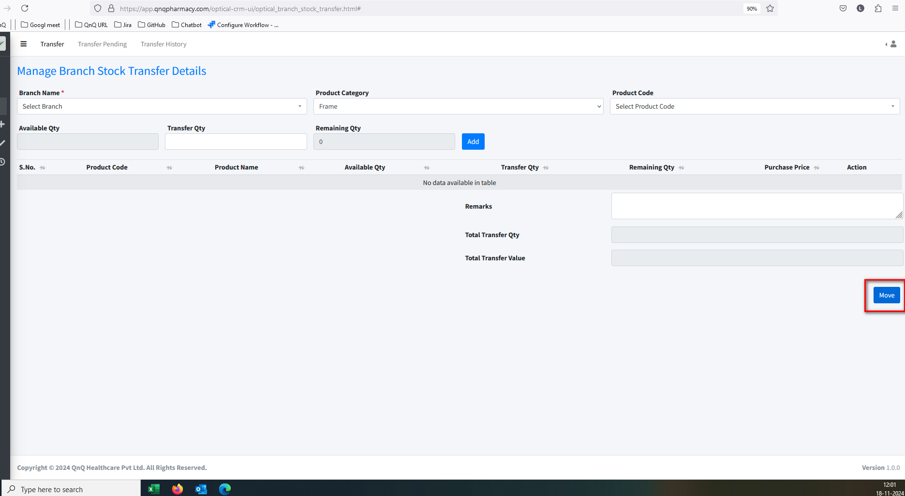//
7. Search option not display in Prd Cat dropdown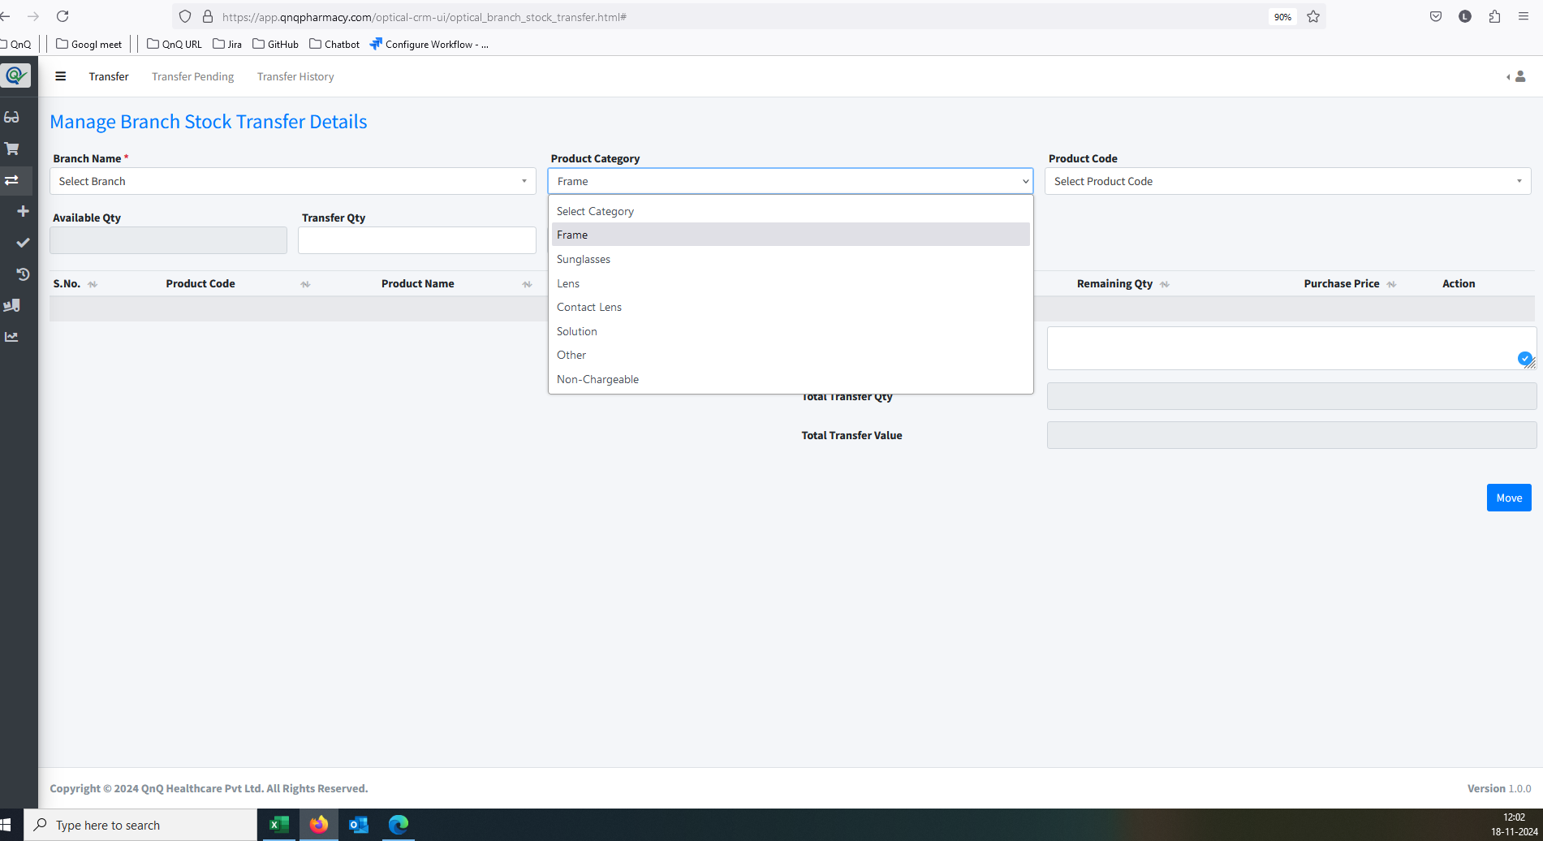//
8. Selected value not getting clear while navigate another grid to same screen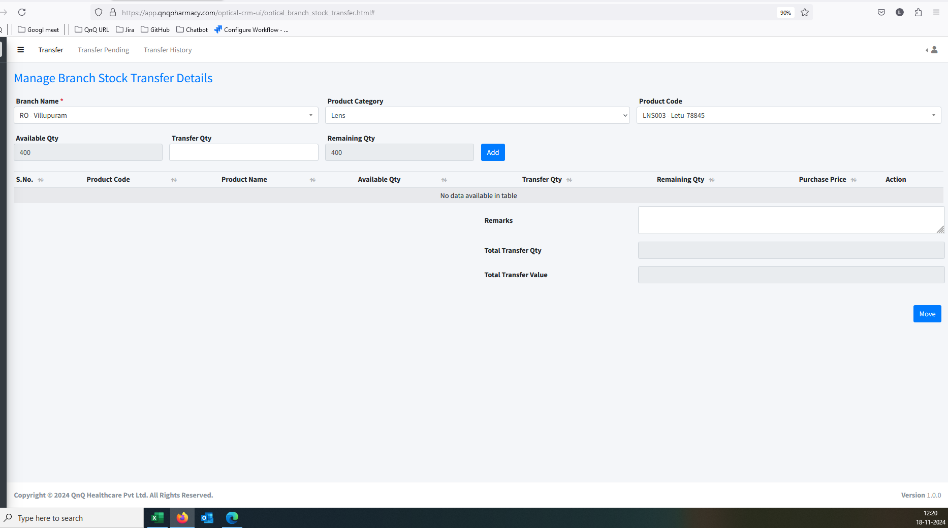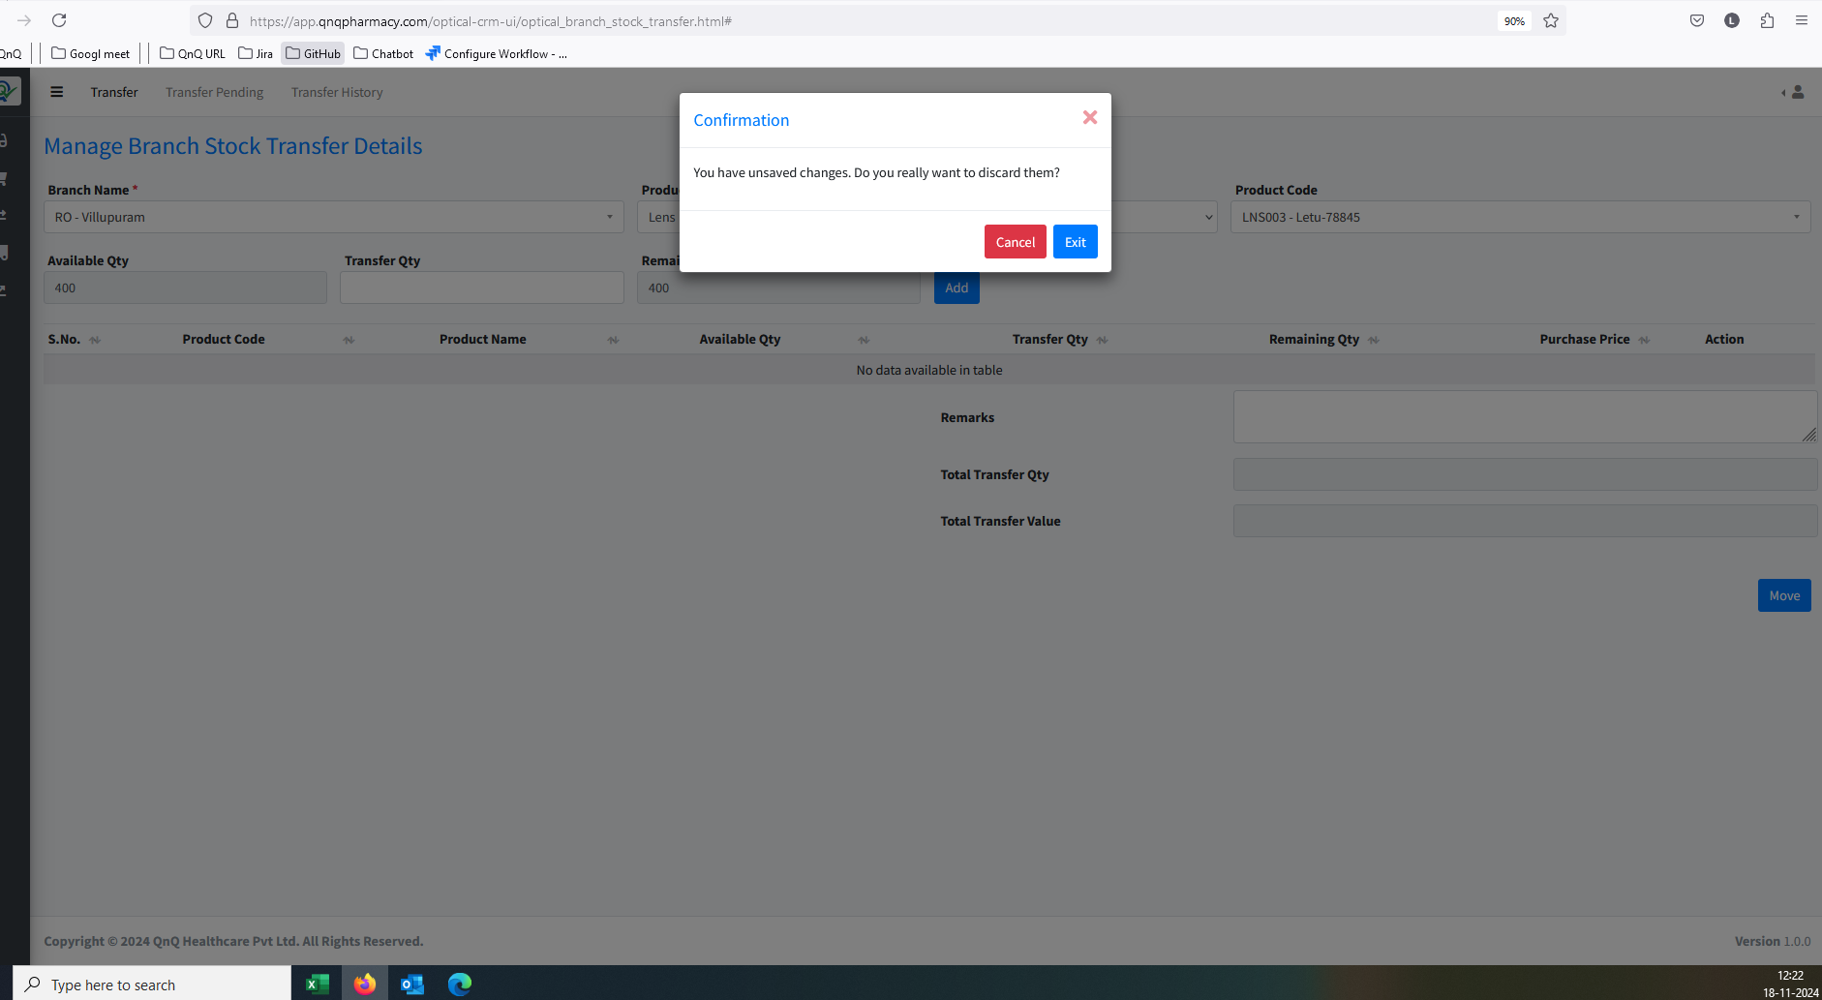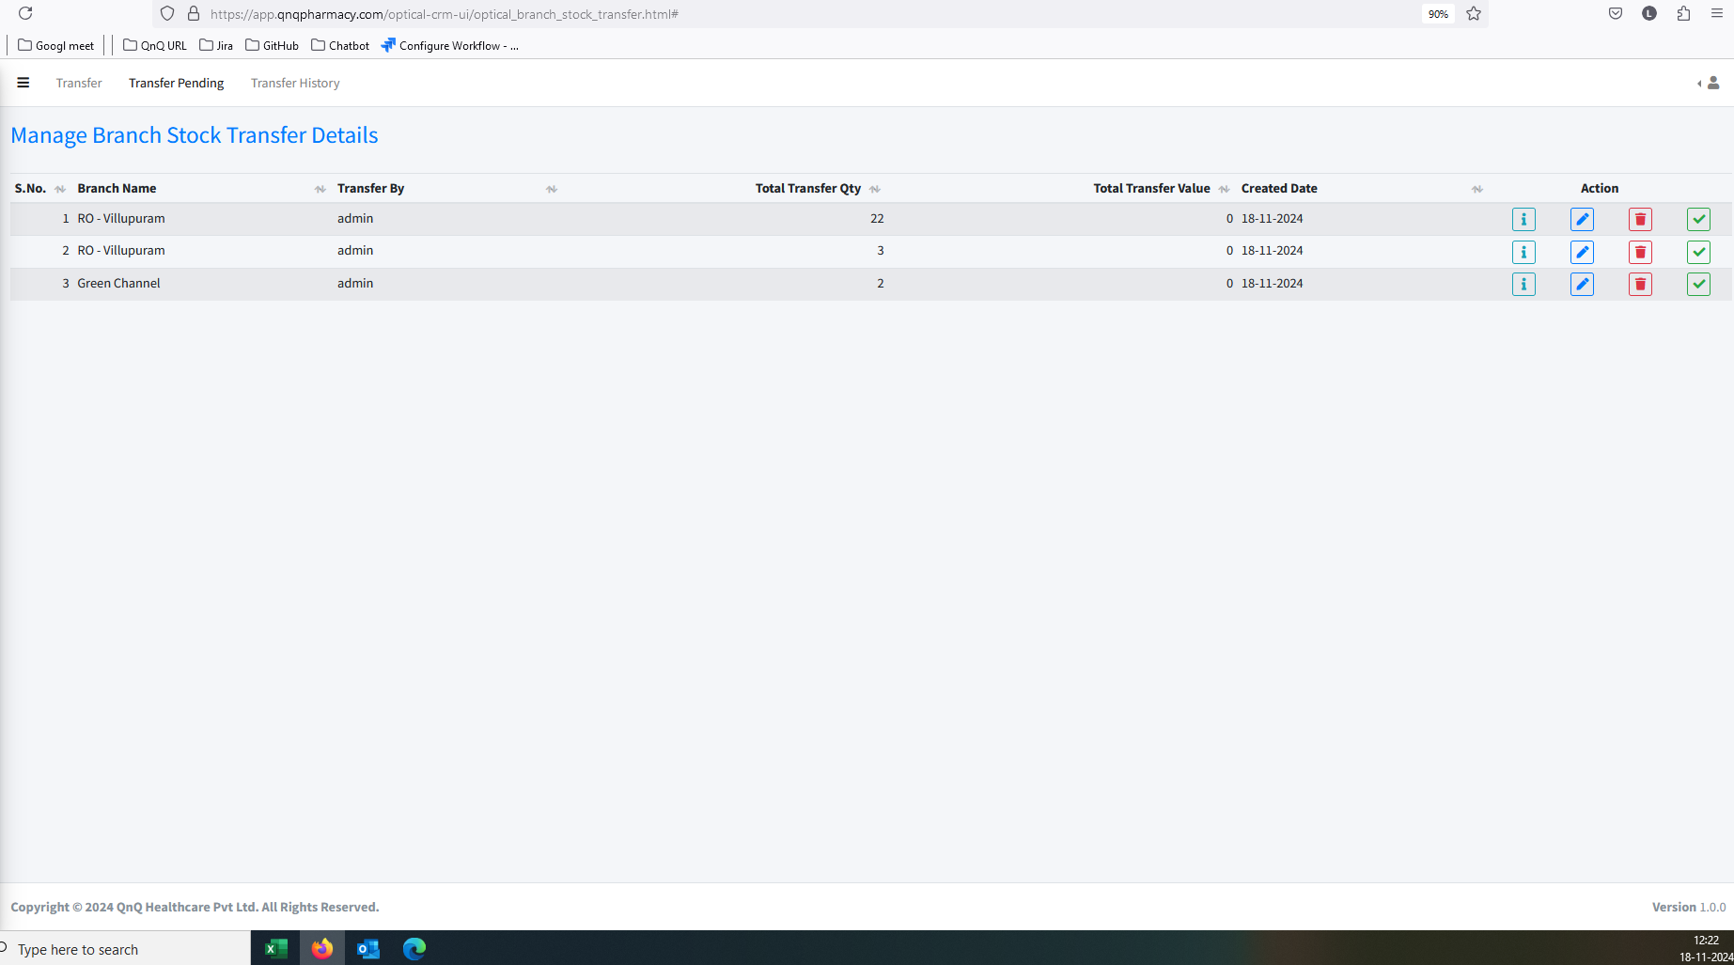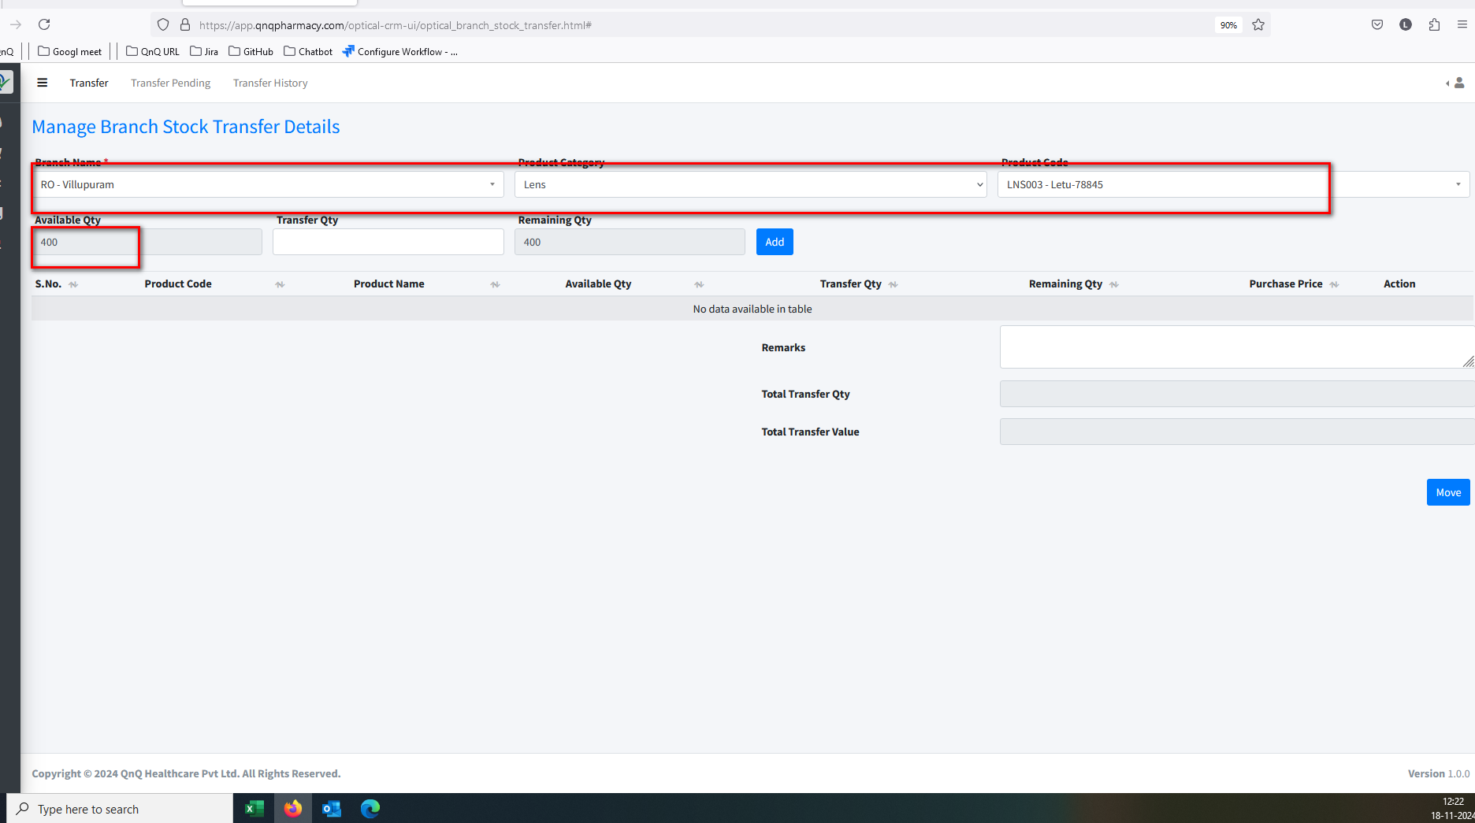//
9. Product line getting add without Transfer Qty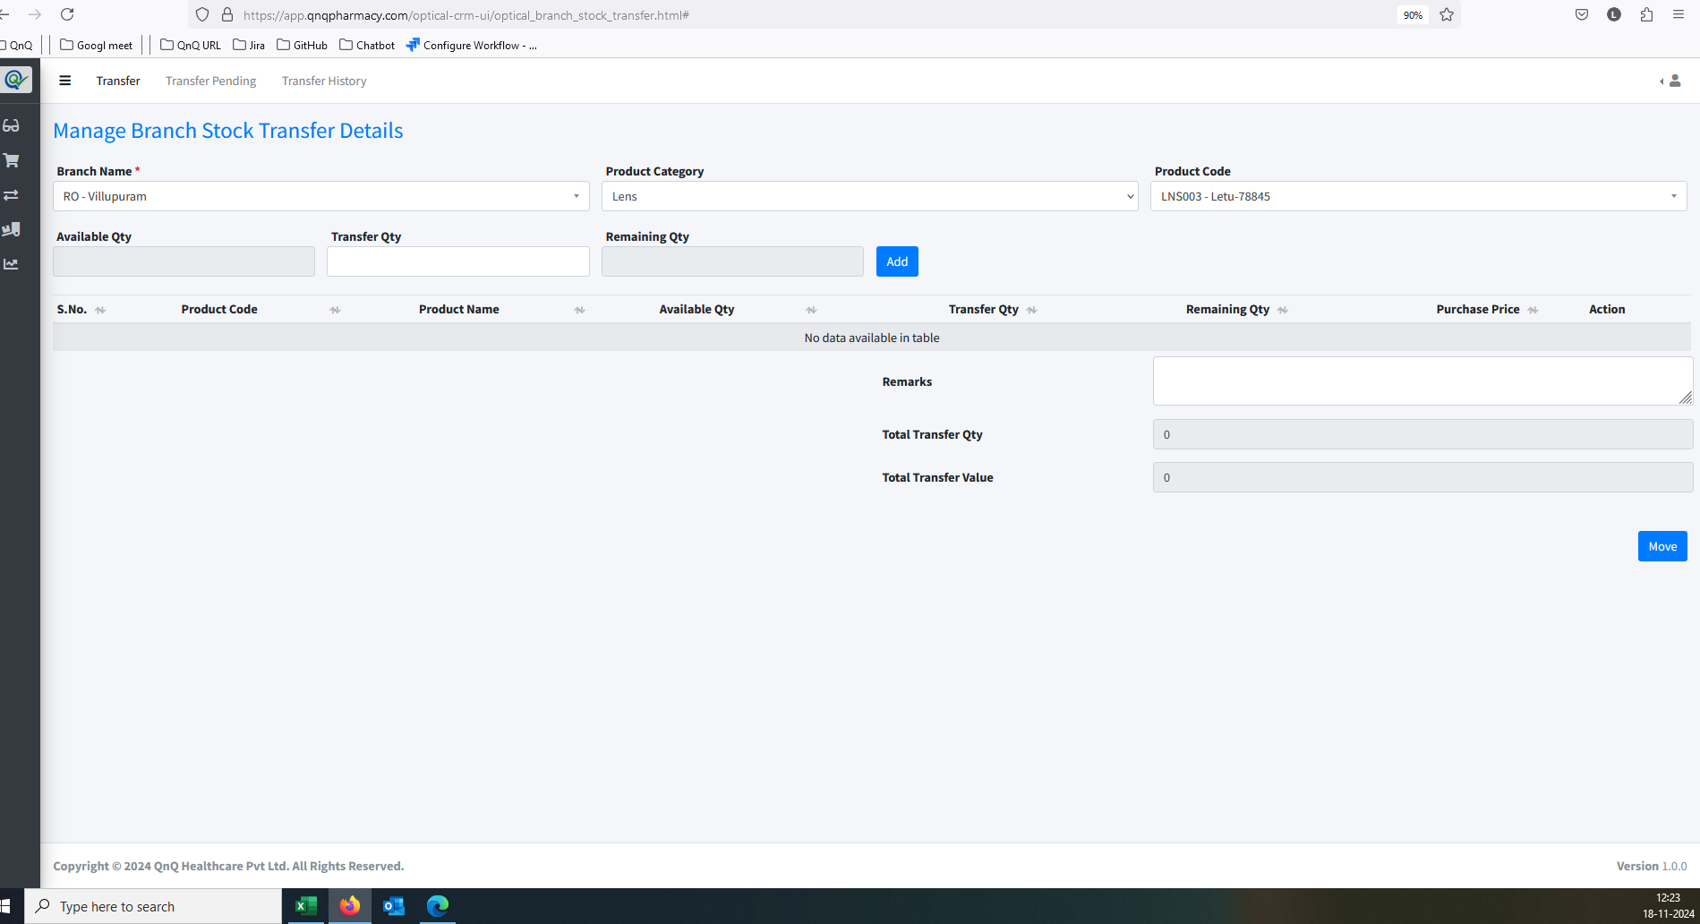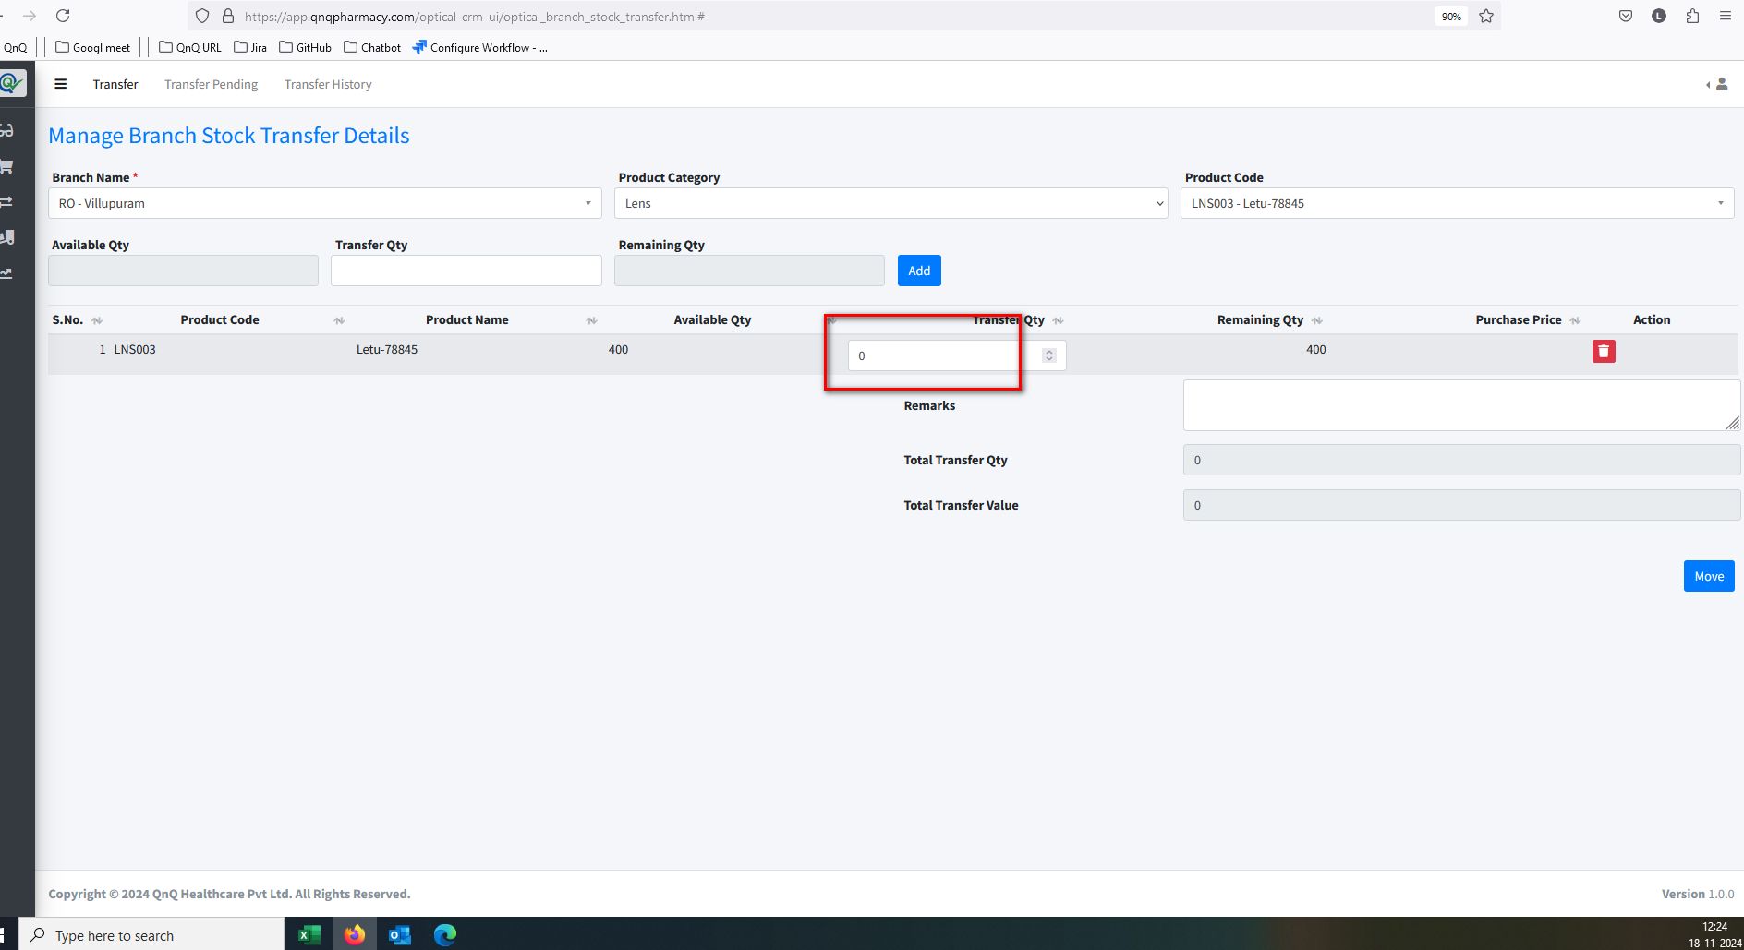//
10. Improper alignment display in list grid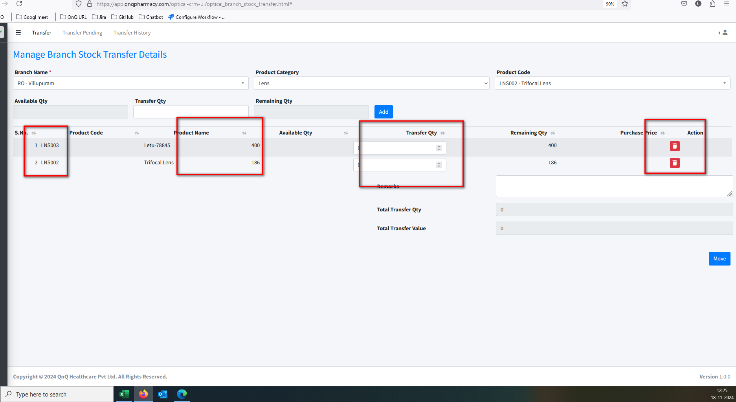//
11. Deleted Product display in Product Code field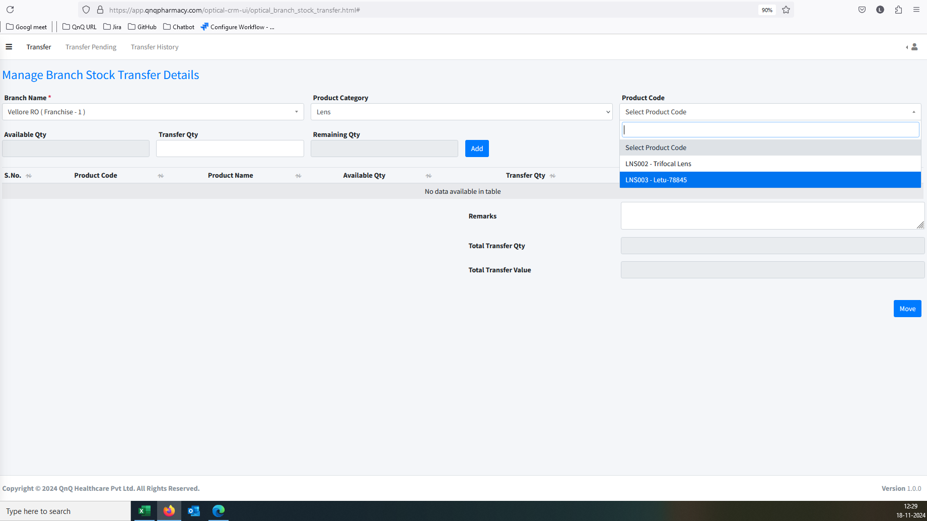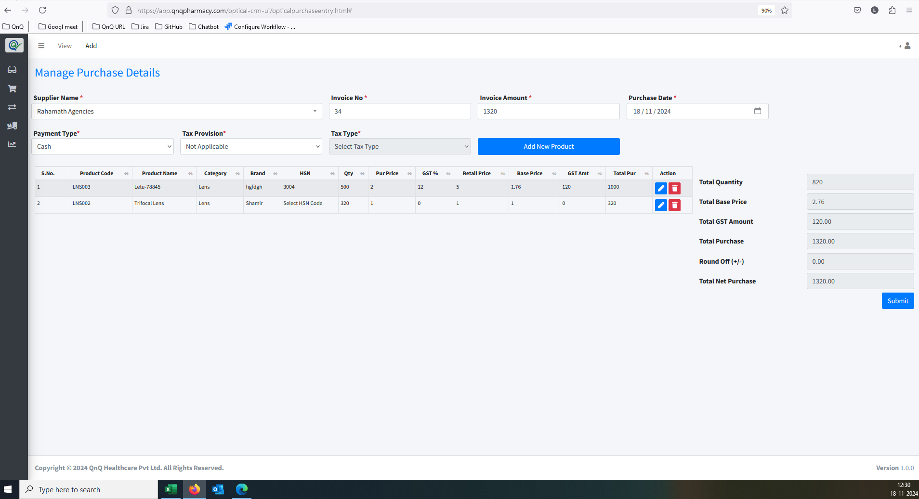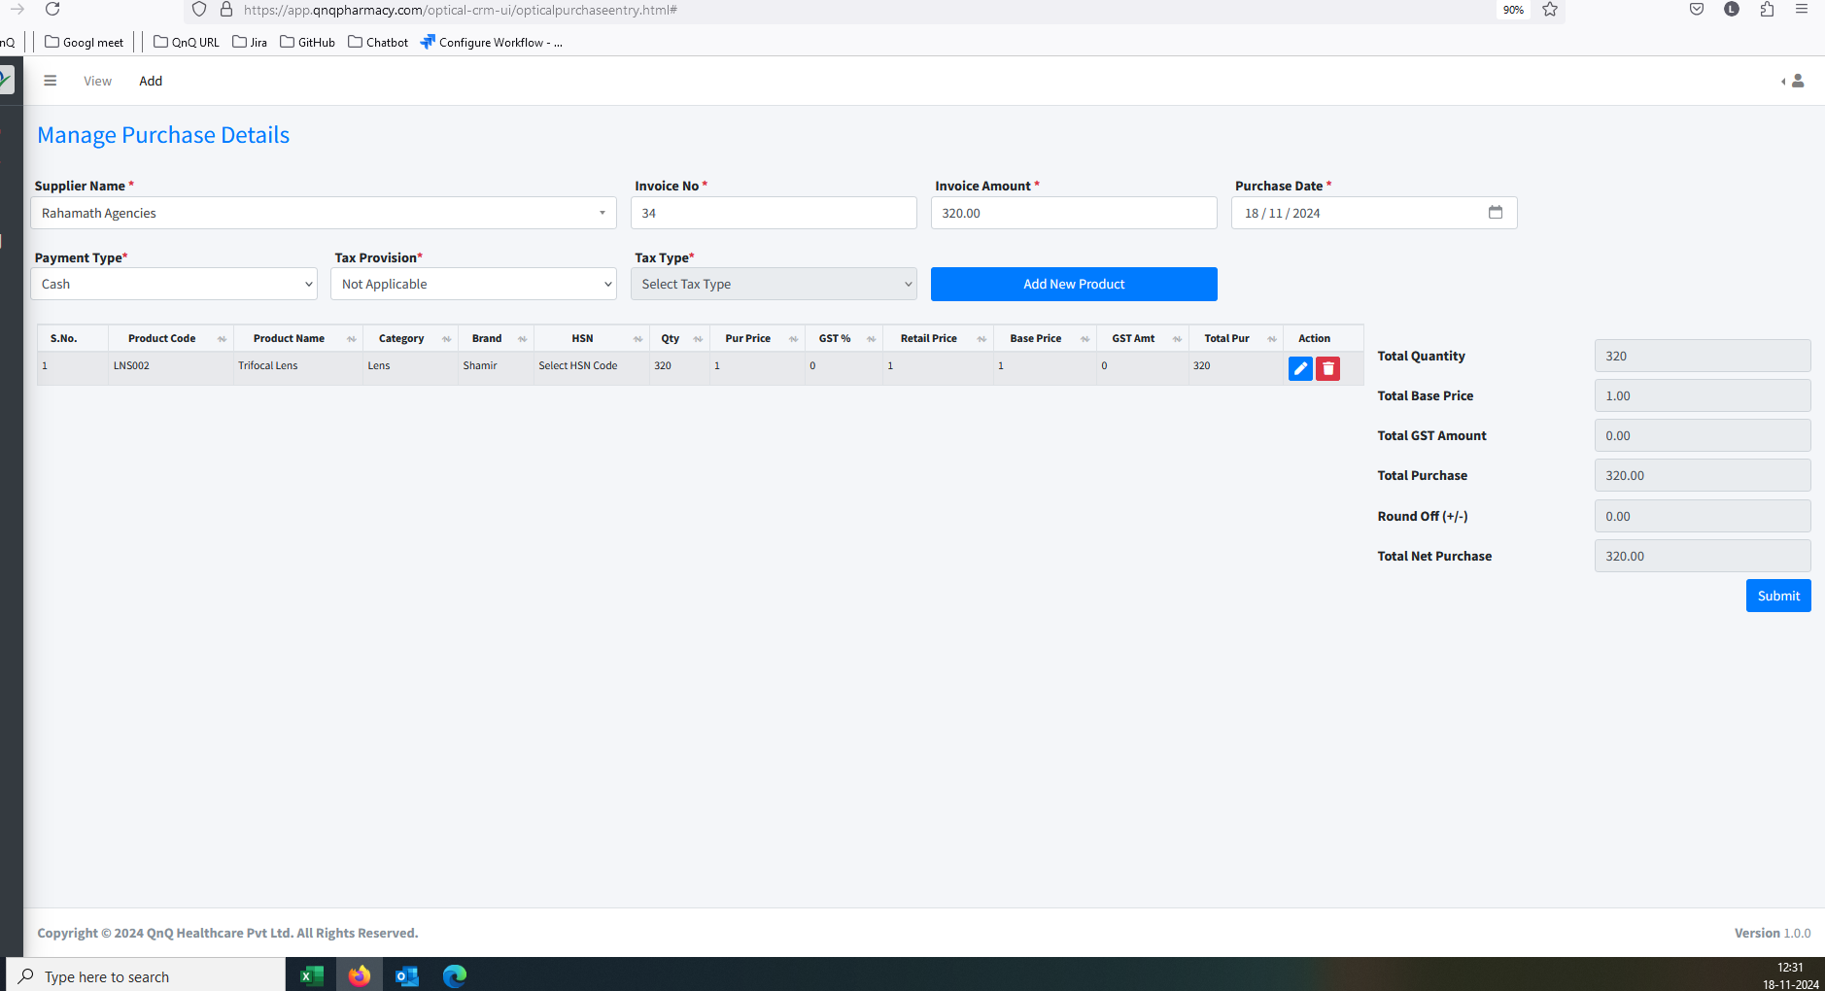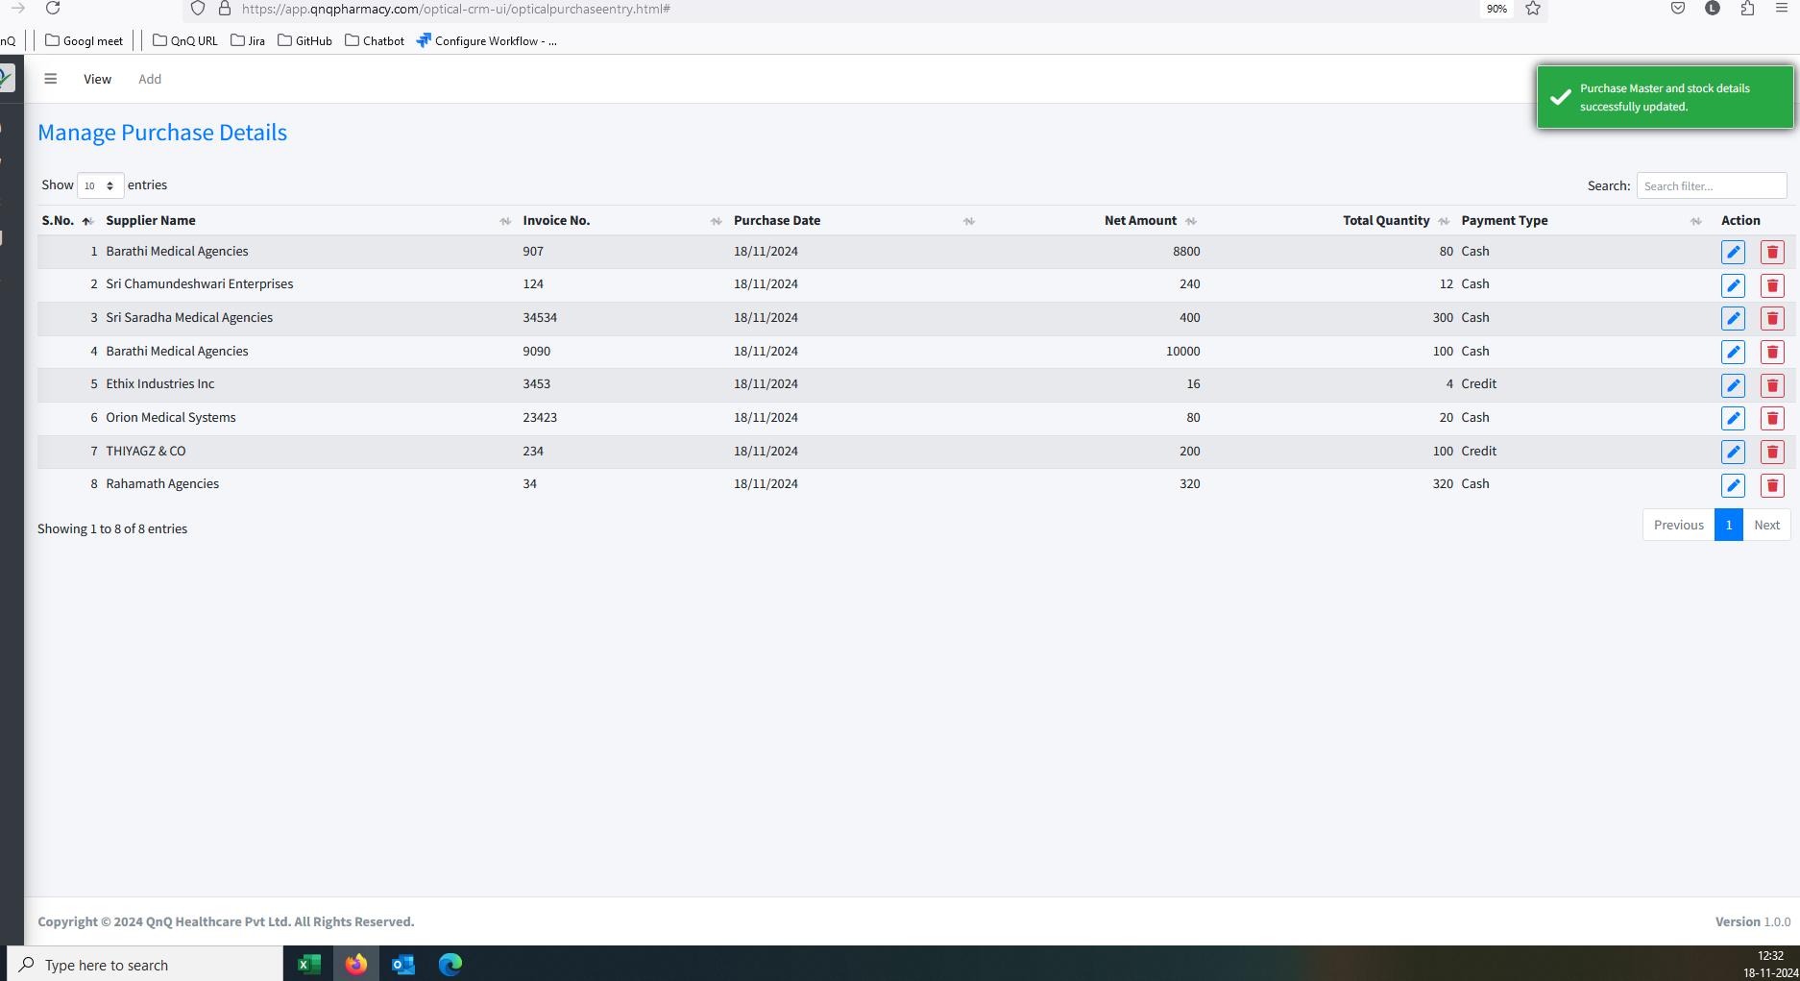

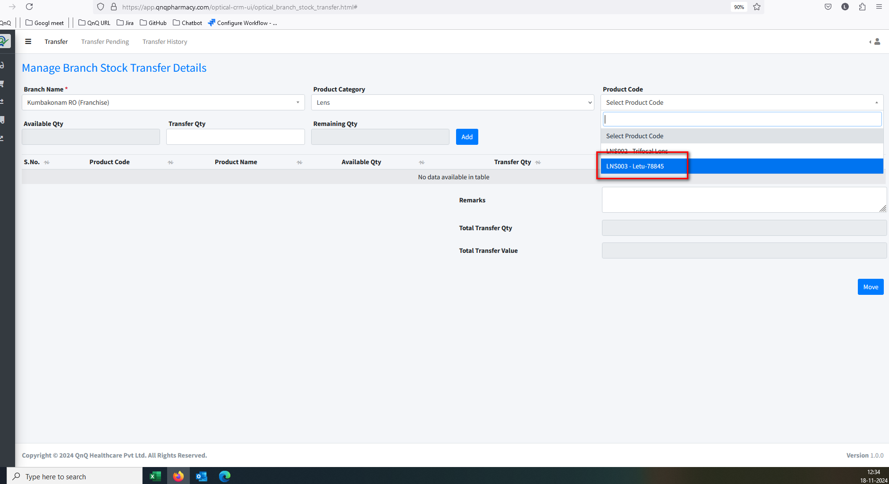

1. Screen header/title name display mismatch content//
2. Column Header, Search filter and Pagination not display//
3. Column value not display in list grid//
4. Placeholder/Inner Text not display in any field //
5. Success message display mismatch content 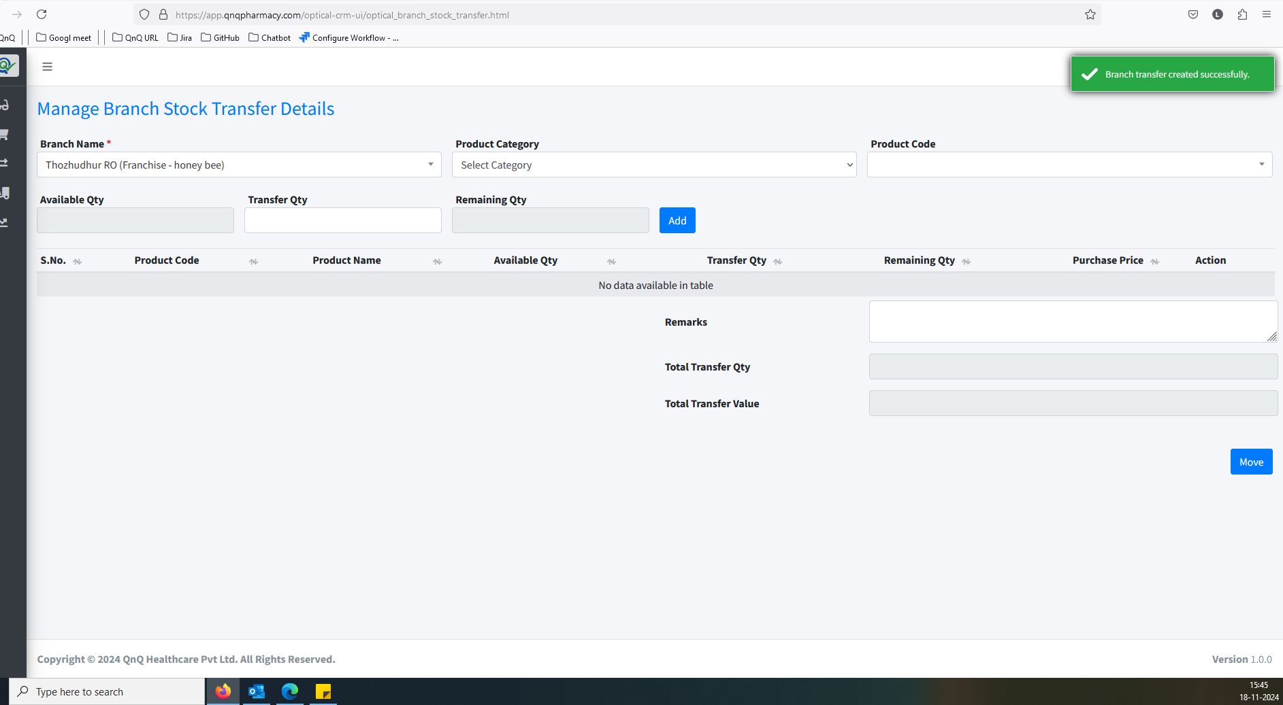 //
6. Update message display mismatch content 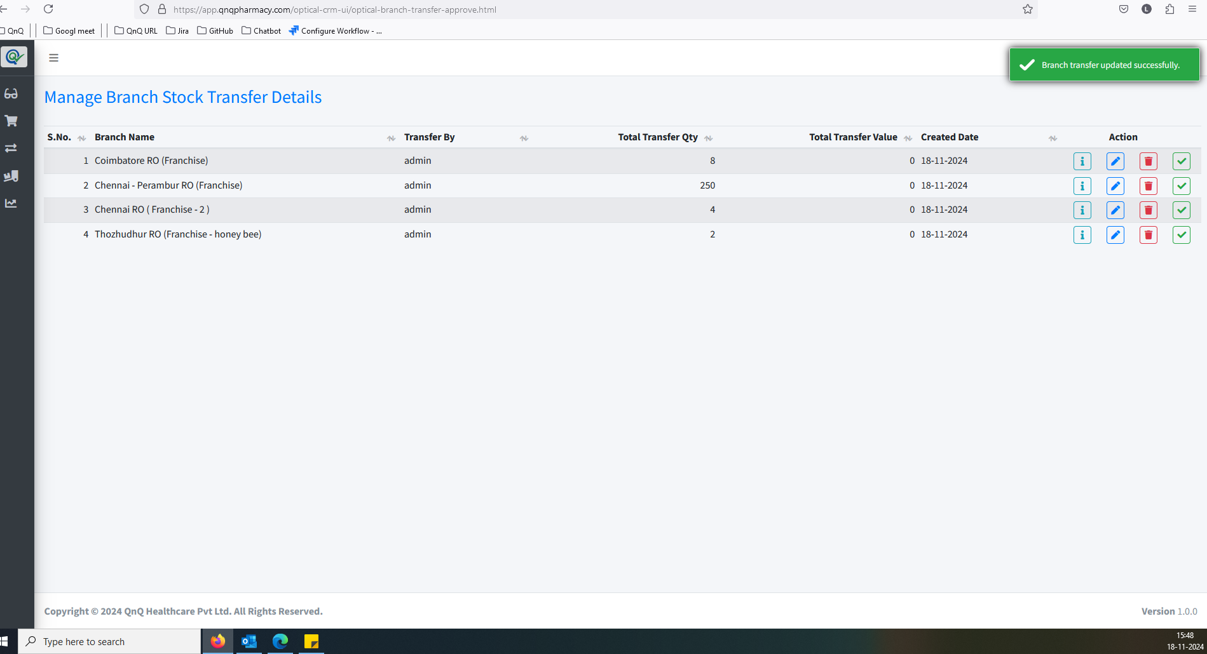 //
7. Delete success message not display while delete the record //
8. Unwanted Title display while click delete icon //
9. Updated success message display without updates any value //
10. Unwanted error message while click submit button with max value 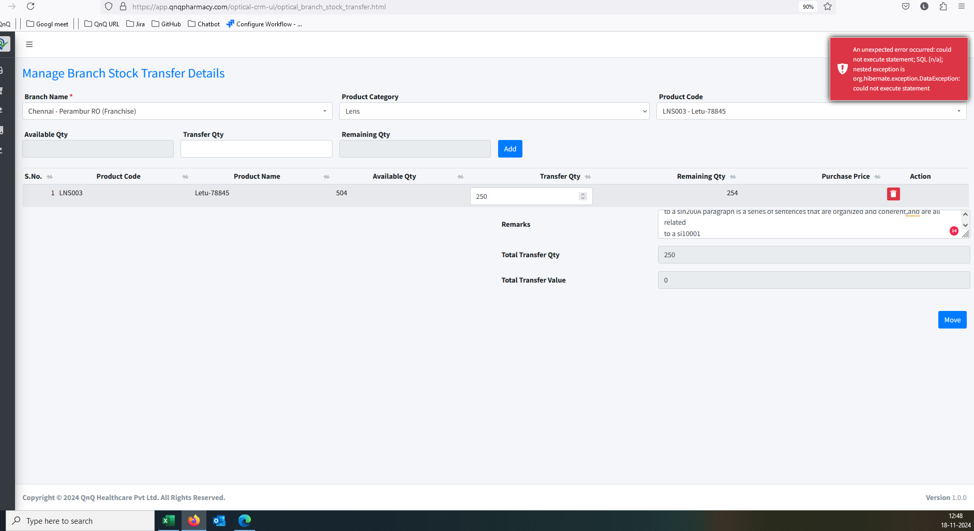//
11. Mismatch column header name display in list grid 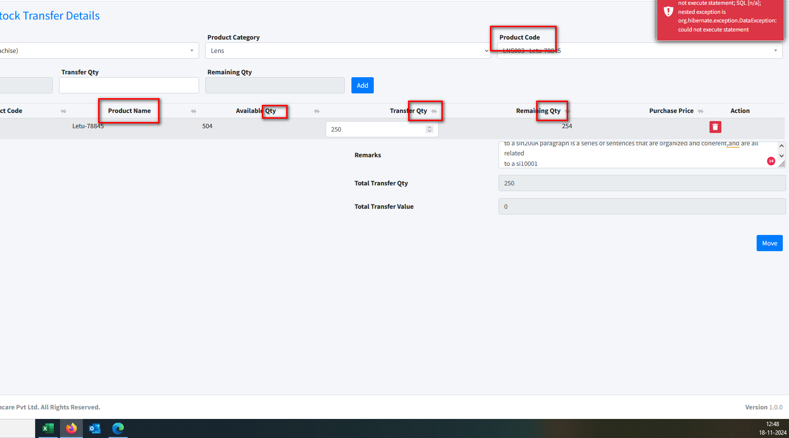//
12. Available Qty display as Empty 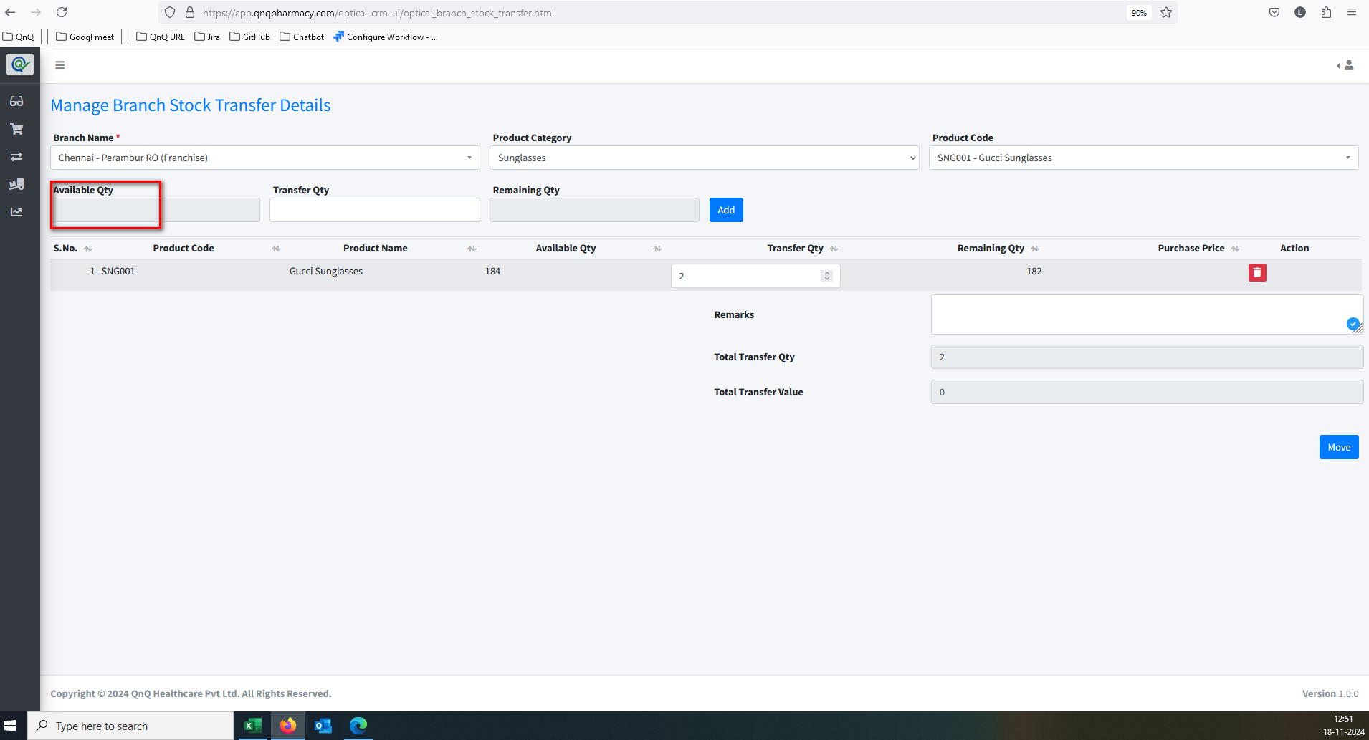//
13. Decimal value allows in Available Qty. field 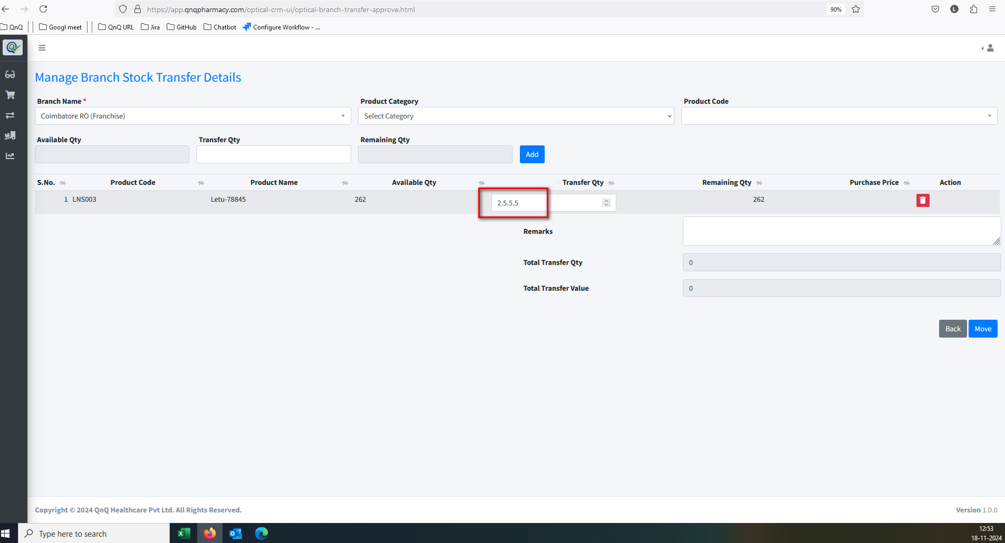//
14. Page not displays within the outer line/Card//
15. Unwanted content display in Delete confirmation pop up 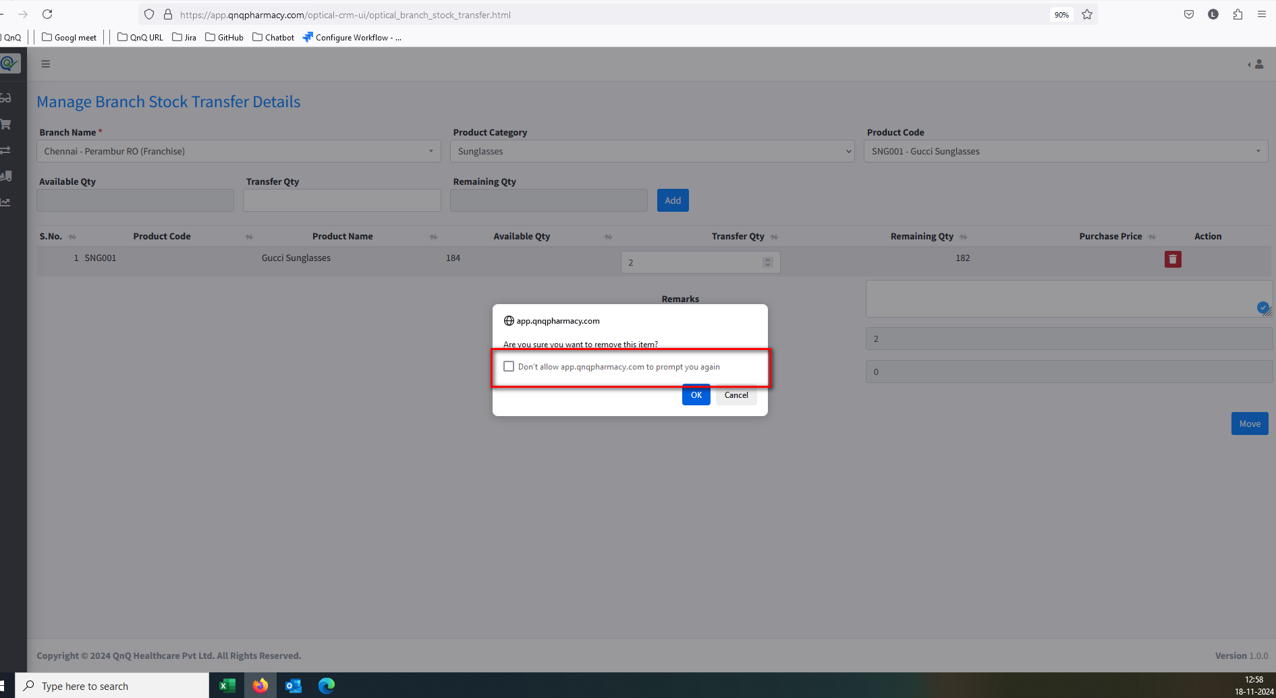 //
16. Confirmation message not display in while click move button without add product value 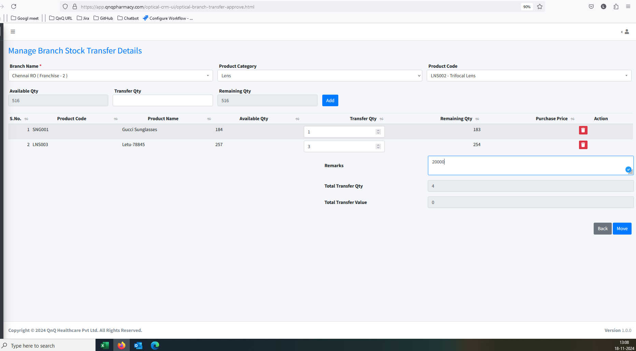 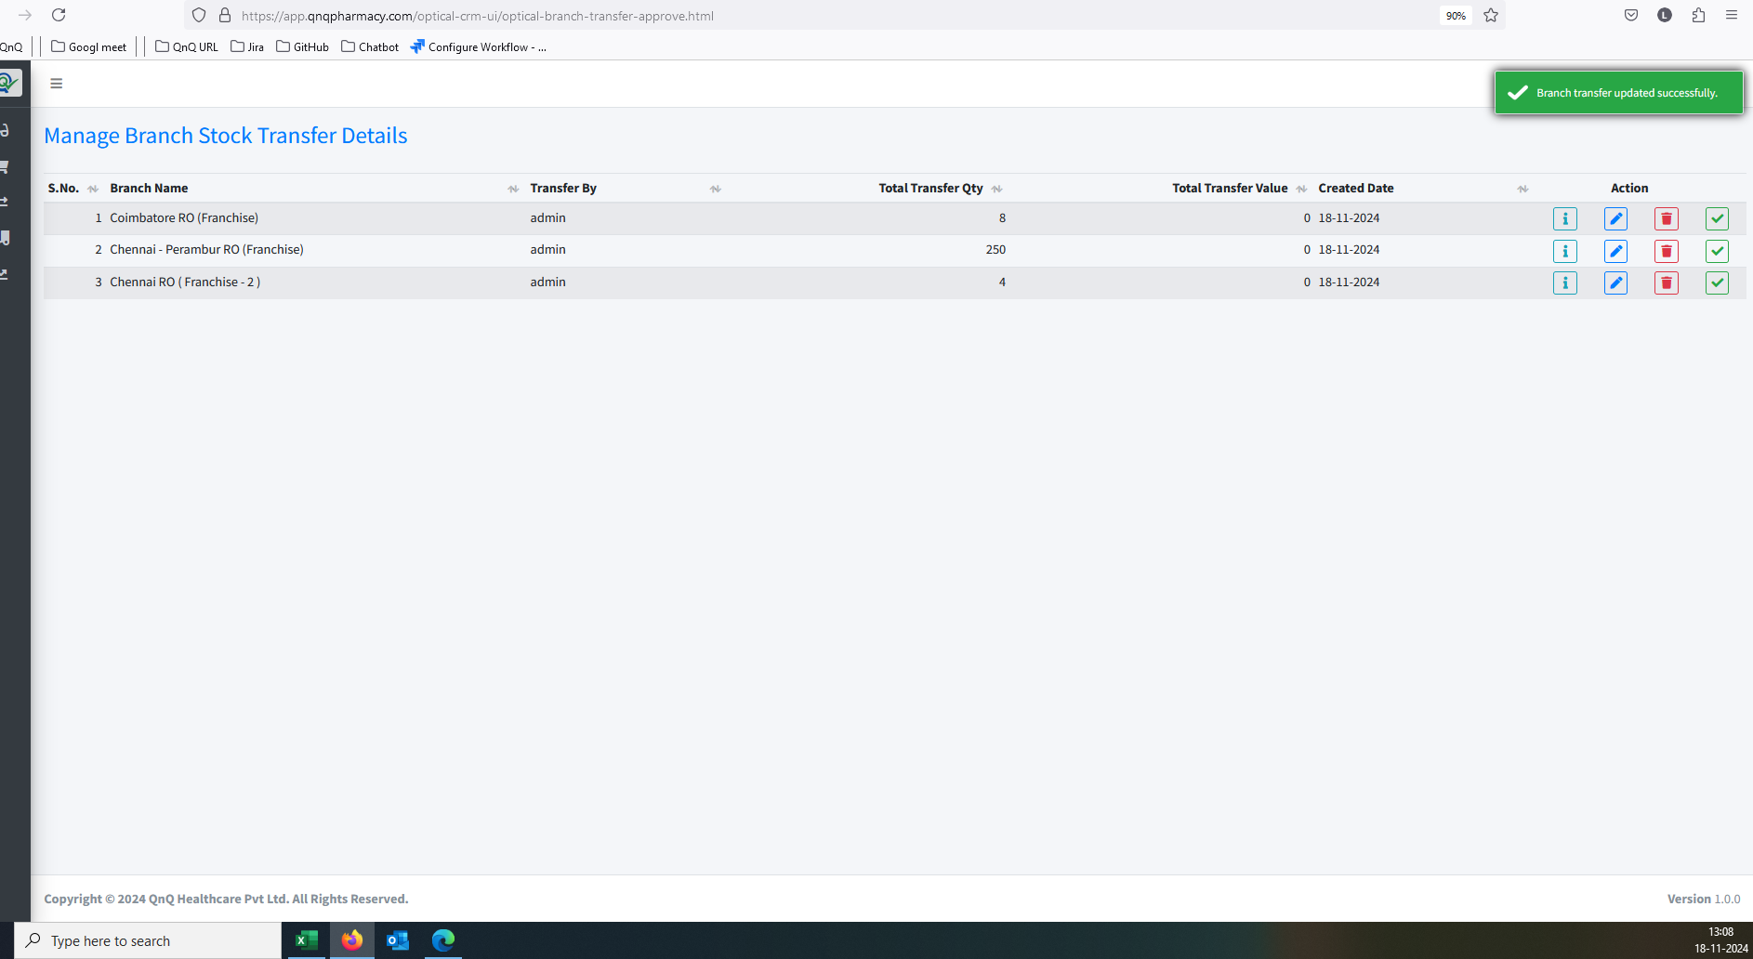 //
17. Recently updated record not display as first record //
18. Button name not display as Update in edit mode //
19. Edit or New batch mode not display in Pop up //
20. Unwanted content display in all dropdown 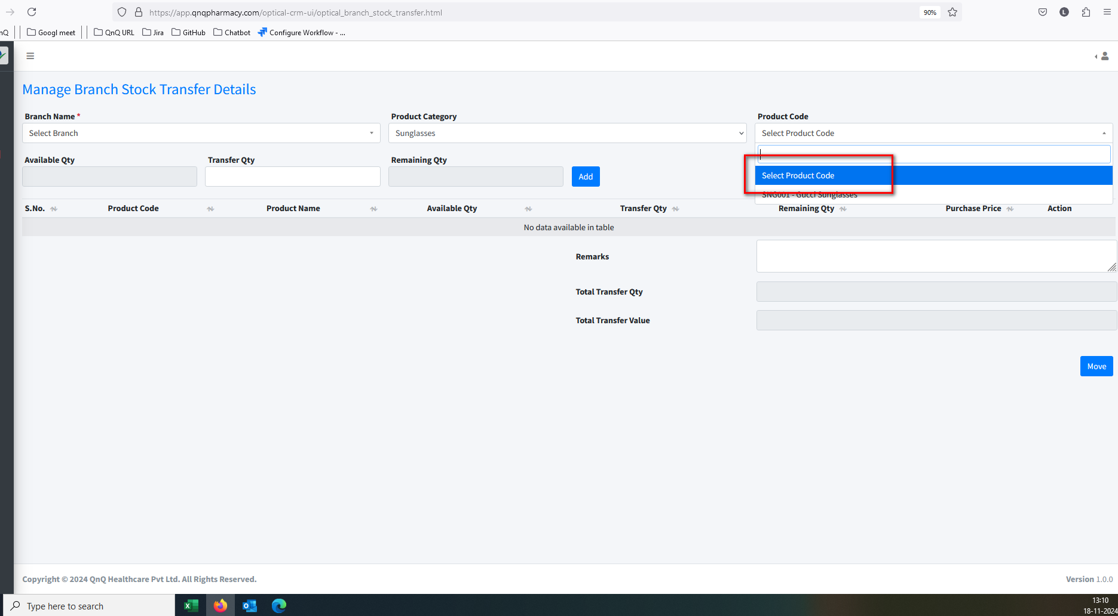 //
21. Unable to update the Trasnfer requested record, when user have not Approve screen access 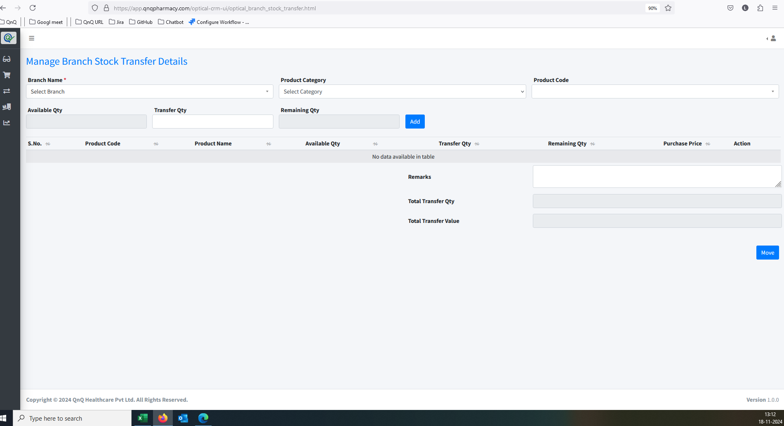 //
22. Total Transfer Value Code display as Empty 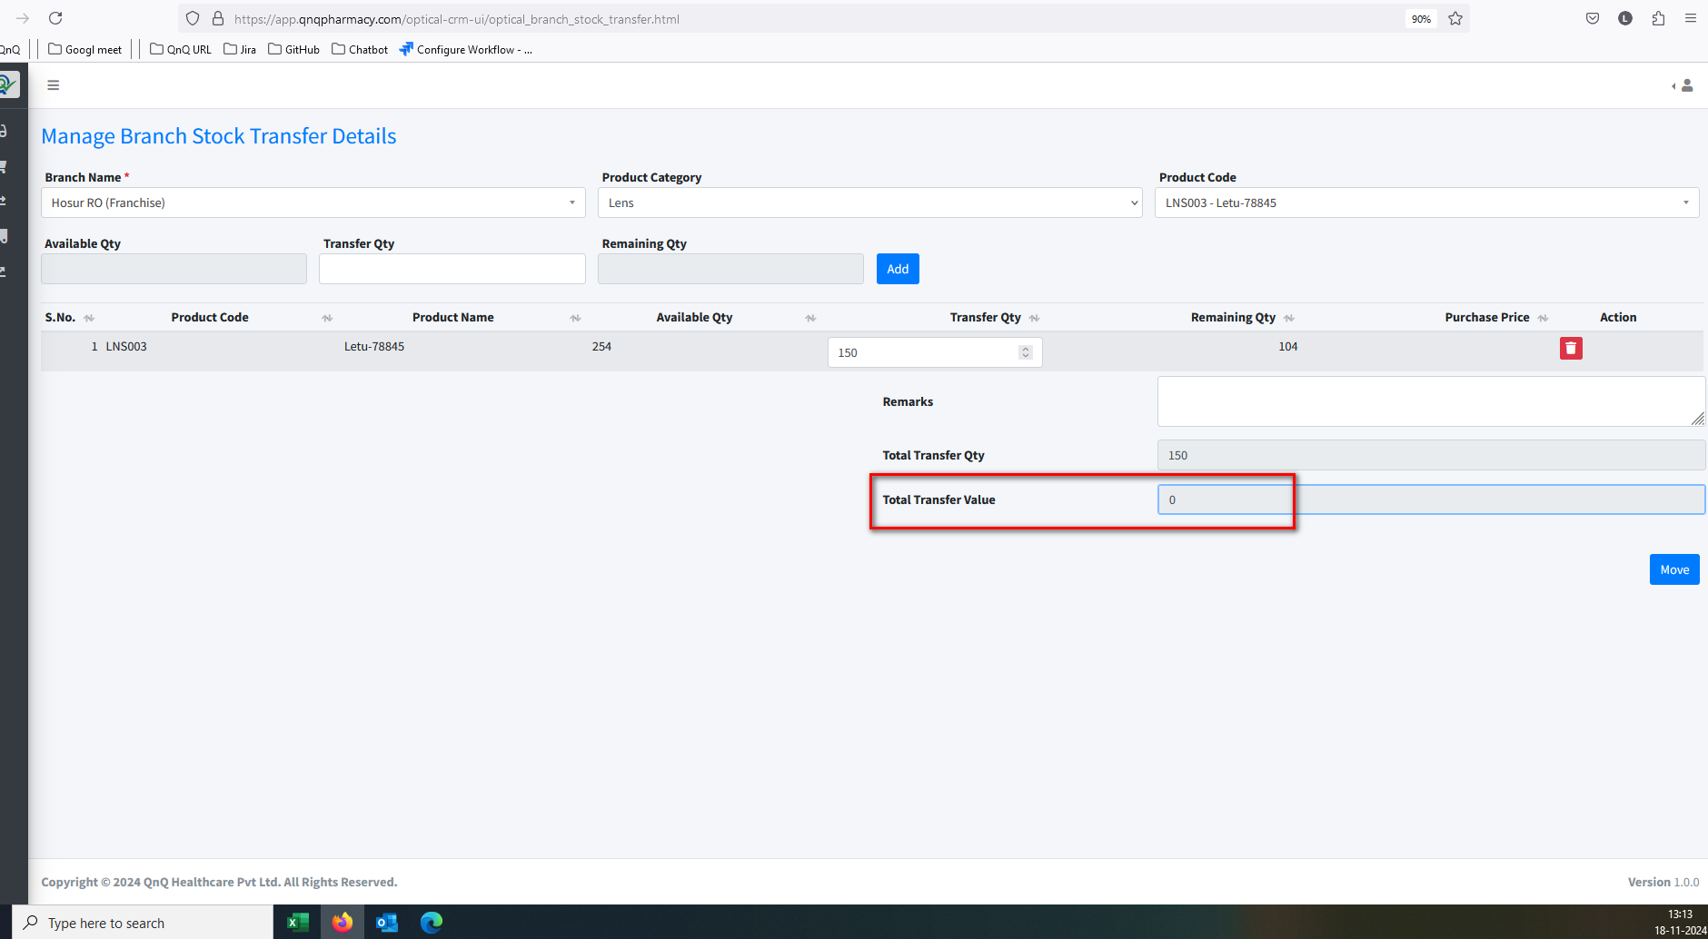 //
23. Mismatch No record available message display in list grid 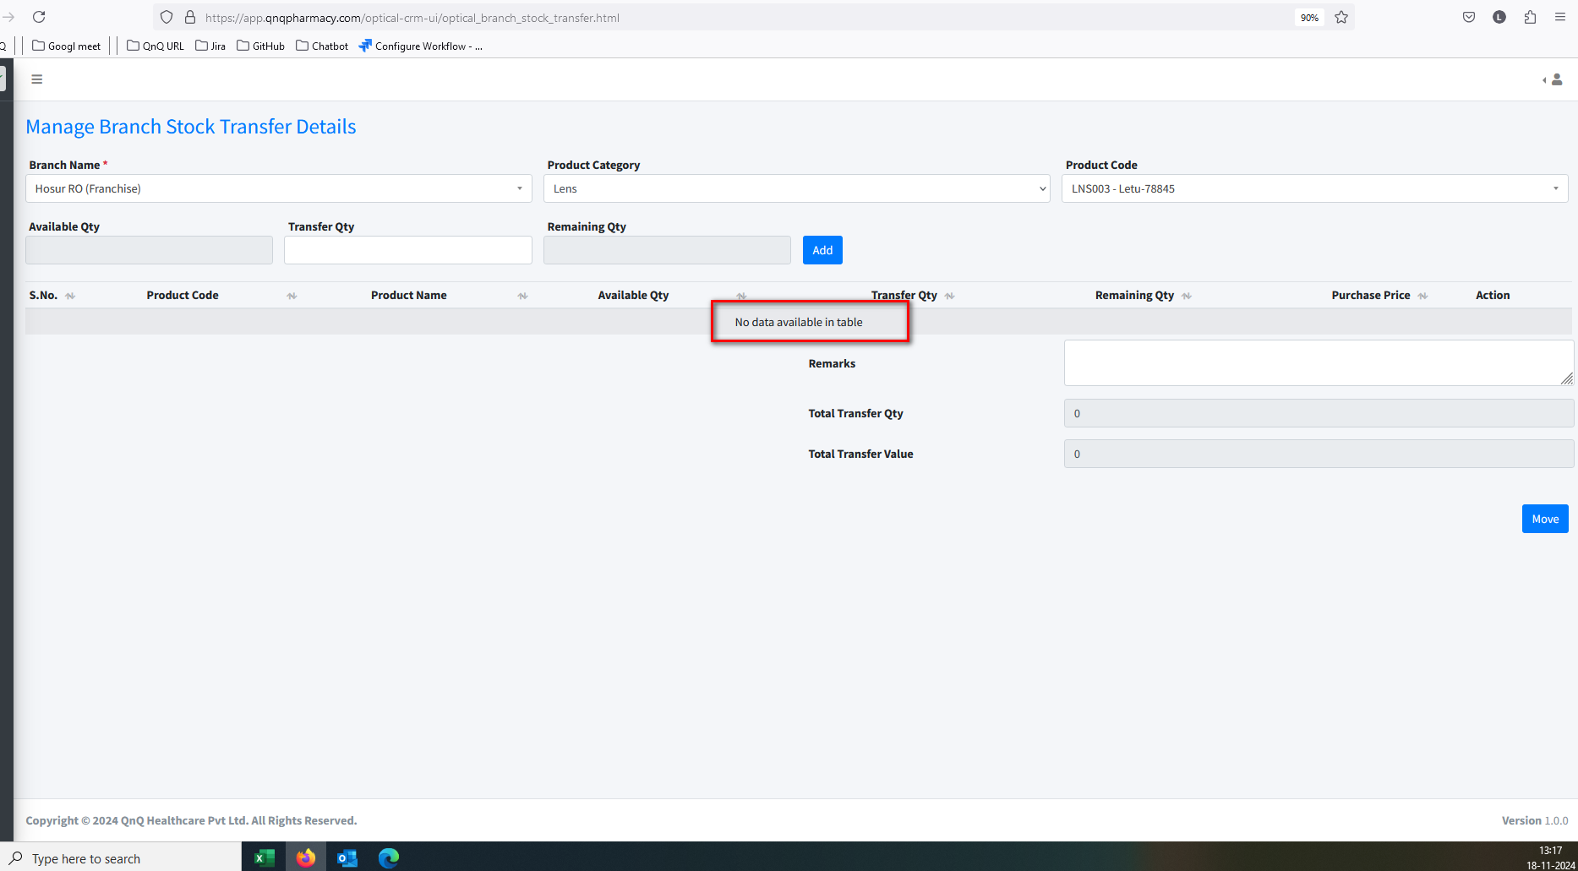 //
24. Unable to update Product category and Product Code values 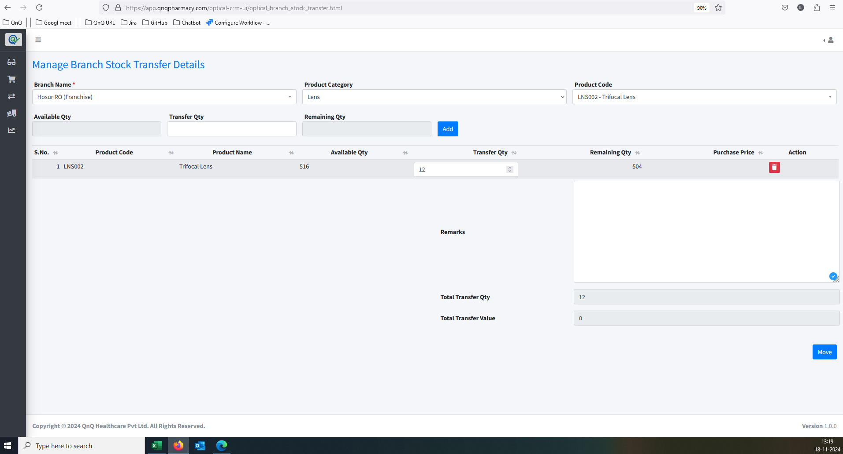 //
25. Multiple error message display 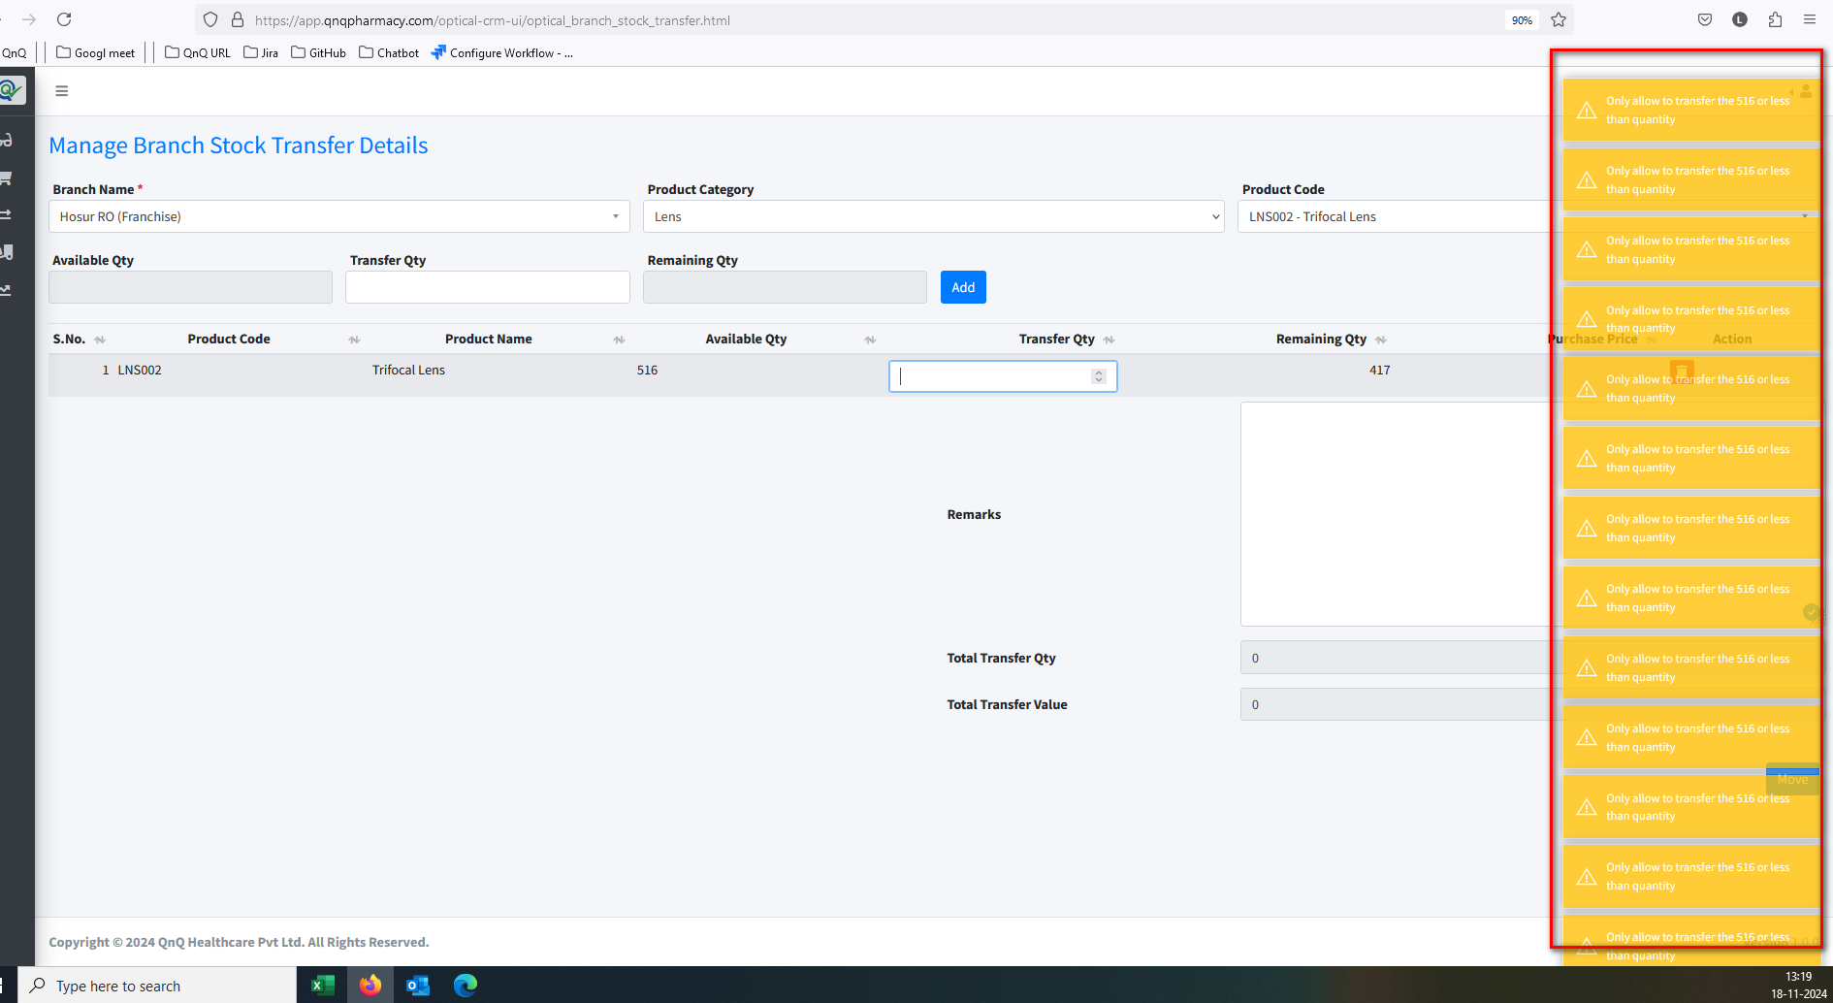 //
26. Unwanted content display in Add button 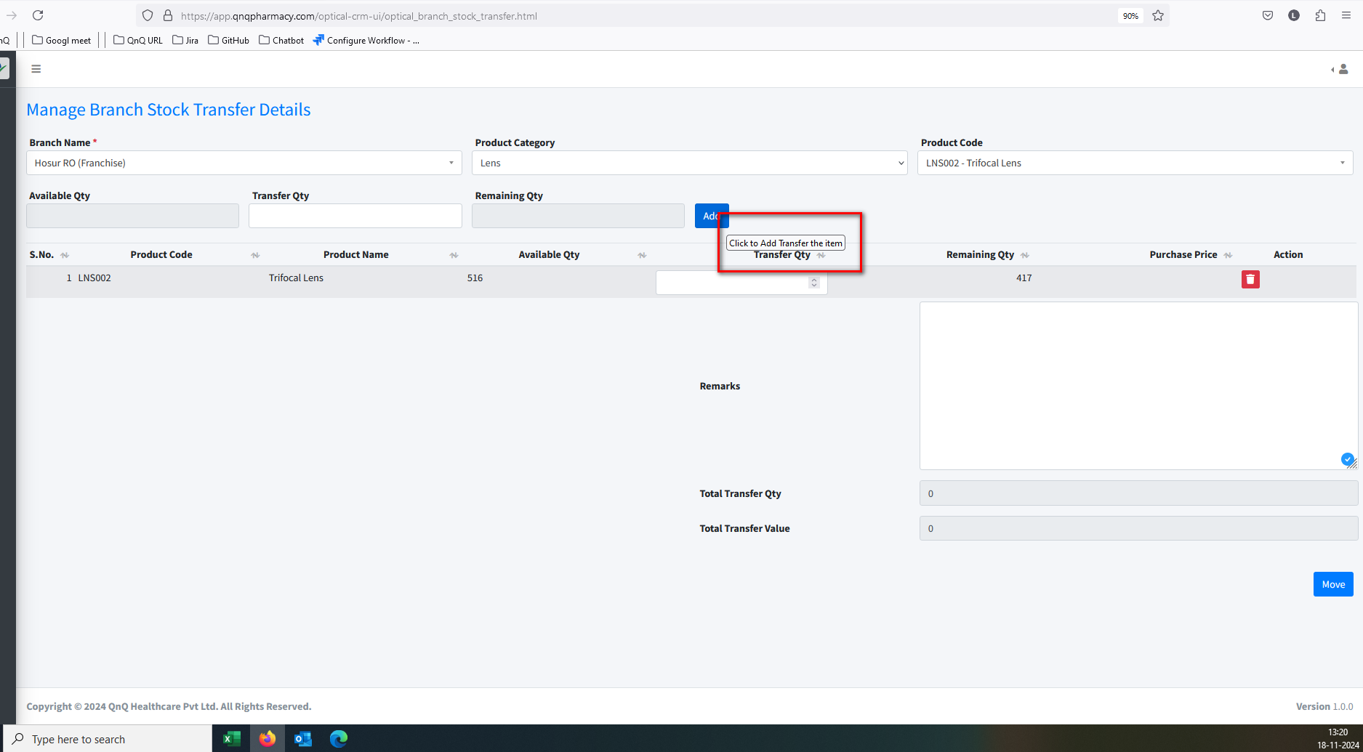 //
27. User can able to request the branch transfer without Branch name 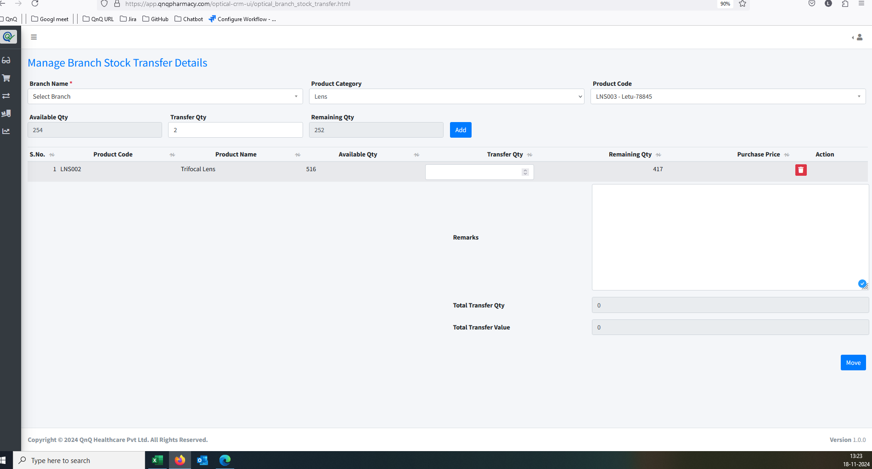 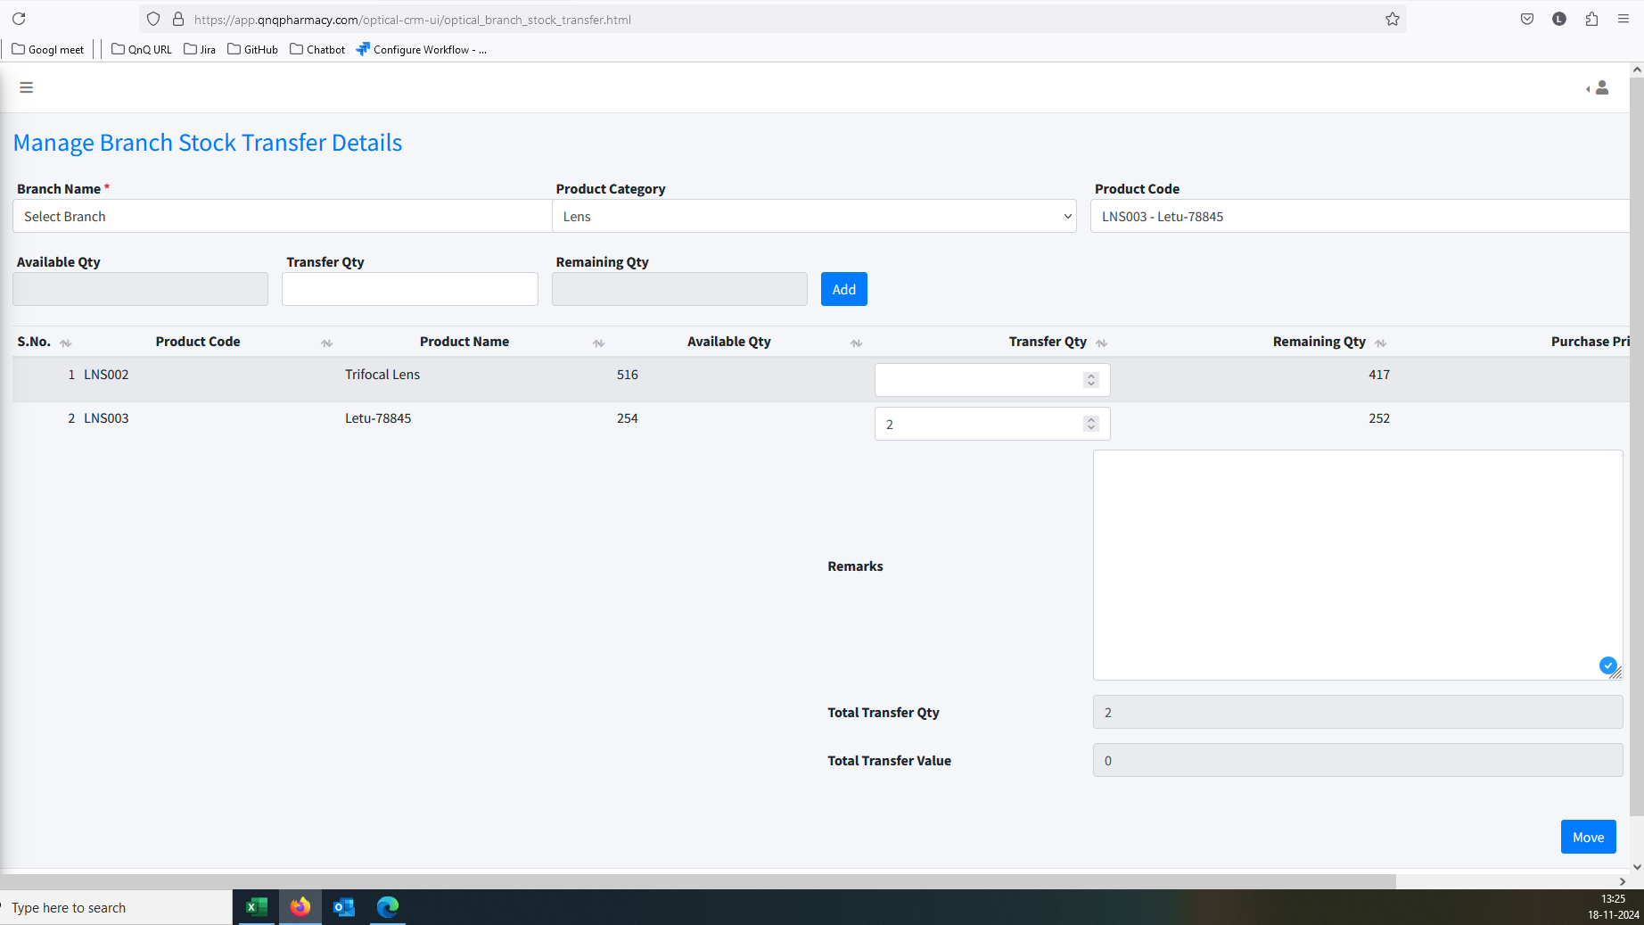 //
28. Remarks field allow more than 1000 values //
29. The navigation suggestion does not appear in the Rate History List grid //
30. Success message not display while create the product